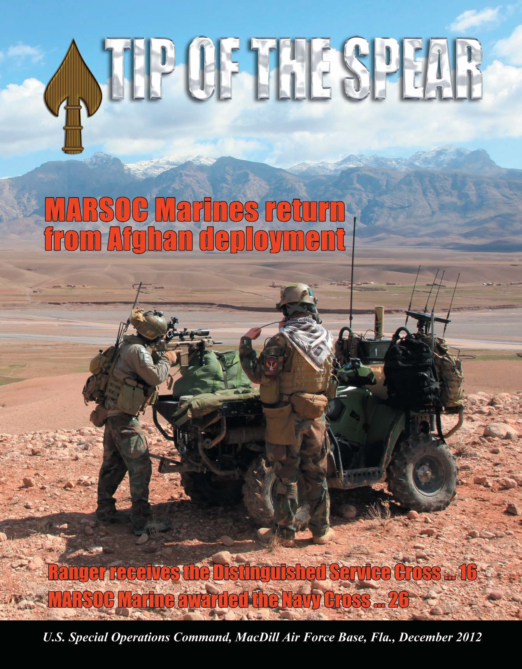

MARSOC Marines return from
Afghan deployment ... 30

Tip of the Spear

Adm. William H. McRaven
Commander, USSOCOM

CSM Chris Faris
Command Sergeant Major
This is a U.S. Special Operations Command publication. Contents are not necessarily the official views of, or endorsed by, the U.S. Government, Department of Defense or USSOCOM. The content is edited, prepared and provided by the USSOCOM Public Affairs Office, 7701 Tampa Point Blvd., MacDill AFB, Fla., 33621, phone (813) 826-4600, DSN 299-4600. An electronic copy can be found at www.socom.mil. E-mail the editor via unclassified network at public.affairs@socom.mil. The editor of the Tip of
the Spear reserves the right to edit all copy presented for publication.

Army Col. Tim Nye
Public Affairs Director

Mike Bottoms
Managing Editor
Marine Corps Master Sgt. F. B. Zimmerman
Staff NCOIC, Command Information

Air Force Master Sgt. Larry W. Carpenter, Jr. Staff Writer/Photographer
Air Force Tech. Sgt. Heather Kelly
Staff Writer/Photographer

Air Force Staff Sgt. Angelita Lawrence
Staff Writer/Photographer

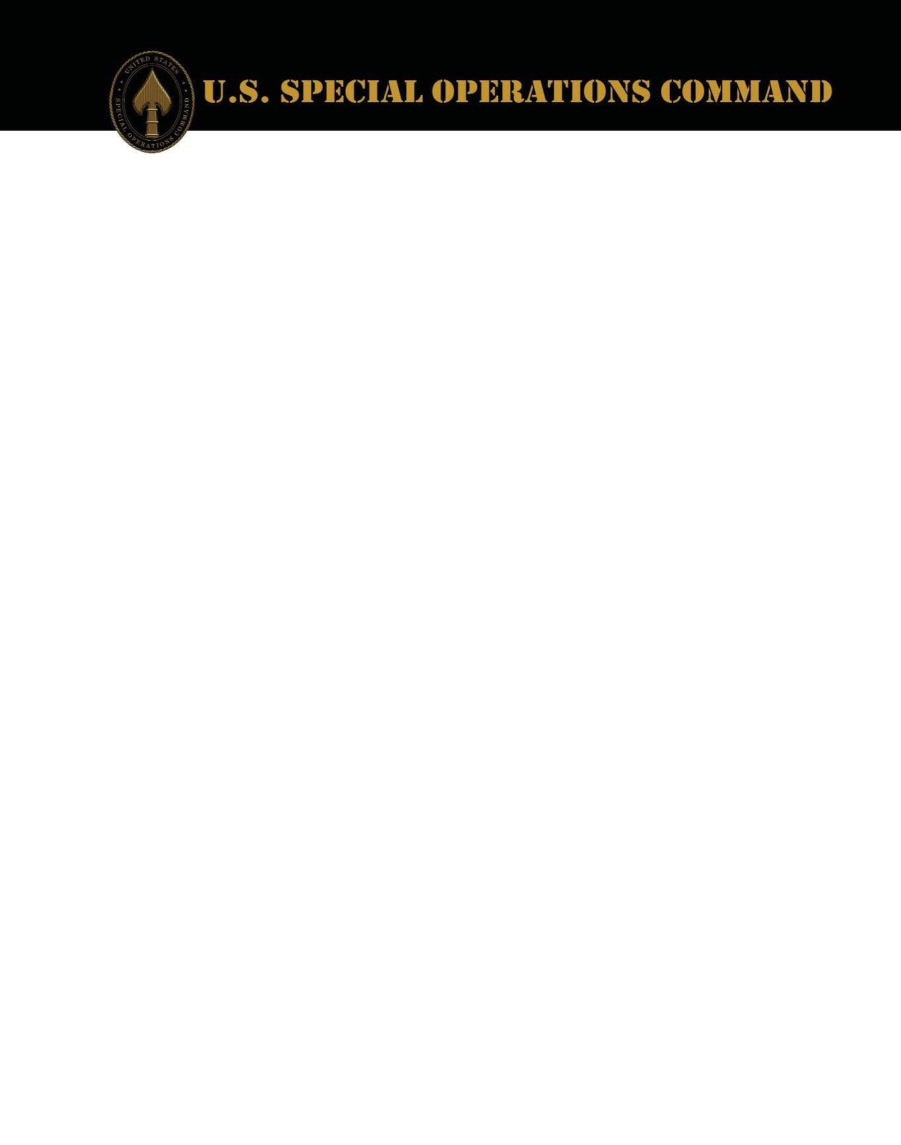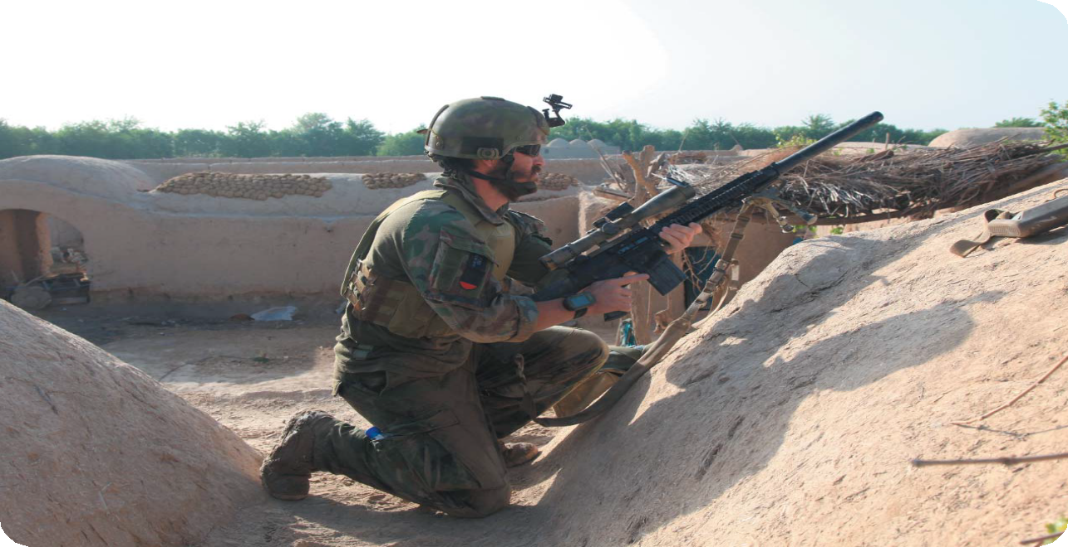
(Cover) Marines with U.S. Marine Corps Forces, Special Operations Command, provide security during a two-day presence patrol with Afghan Commandos in Farah province Feb. 27. Marines with MARSOC's 1st Marine Special Operations Battalion recently returned from a nine-month deployment to Afghanistan, where they commanded the Special Operations Task Force - West and oversaw one of Afghanistan's bloodiest regions. Photo by Marine Corps Cpl. Kyle McNally.

T i p o f t h e S p e a r
2

Highlights

Ranger receives Distinguished
Service Cross ... 16

UDT - SEAL Museum hosts
27th annual muster ... 20

MARSOC Marine awarded the Navy Cross ... 26

Departments

Special Feature

2012 imagery year in review ... 4

U.S. Army Special Operations Command

Ranger receives Distinguished Service Cross ... 16

Naval Special Warfare Command

UDT - SEAL Museum hosts 27th annual muster ... 20

Air Force Special Operations Command

EOD tech earns Silver Star ... 22

Former CSAF nominated for the Order of the Sword ... 23

Past, present SOWTs shape elite career field ... 24

Marine Corps Forces Special Operations Command

MARSOC Marine receives Navy Cross ... 26

MARSOC Marines return from Afghan deployment ... 30

Headquarters

SOCOM wins Better Buying Power Efficiency Award ... 34

History: Founding of Joint Special Operations University ... 36

Fallen Heroes ... 39

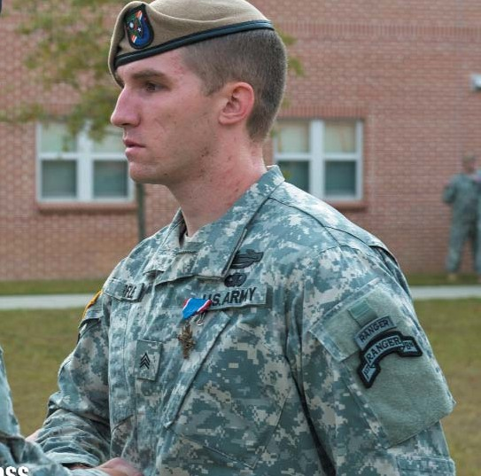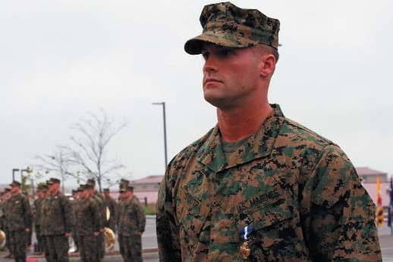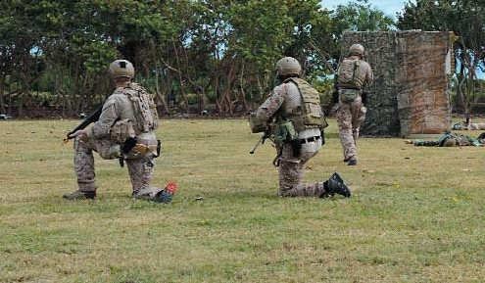

T i p o f t h e S p e a r
3

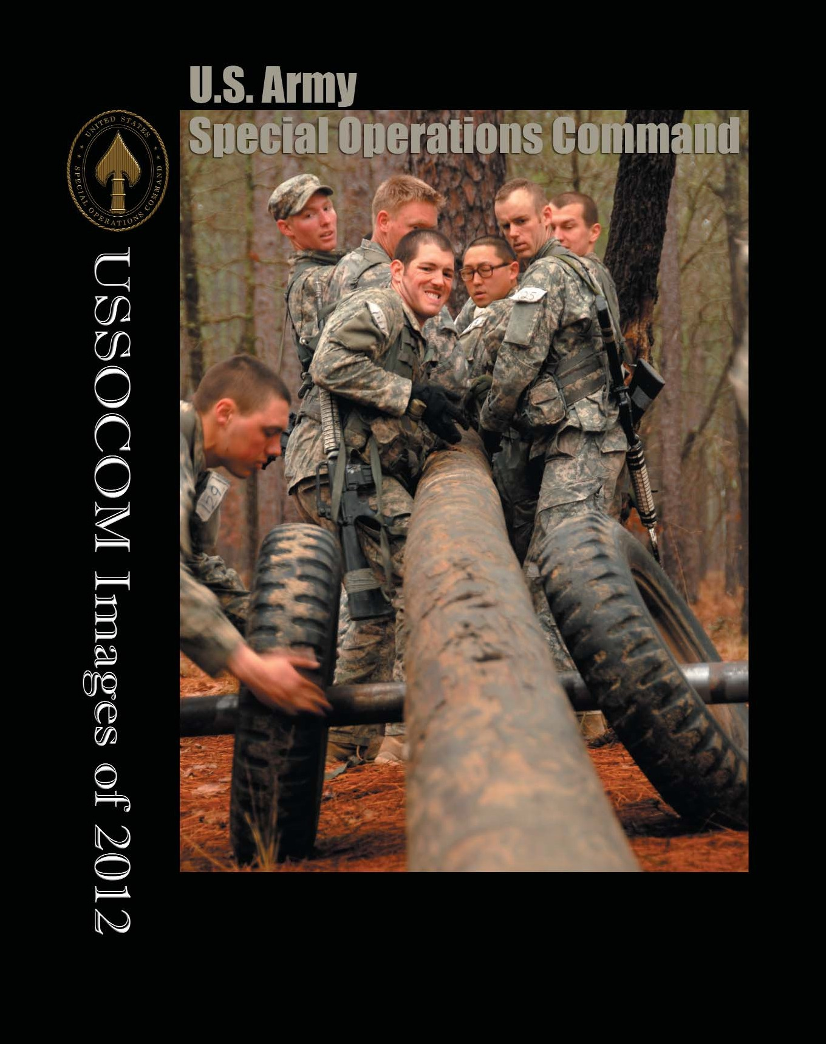

Candidates work together to break down a make shift vehicle during the Team Week phase of the Army Special Forces Assessment and Selection course, Jan. 22, in the woods of North Carolina near Camp Mackall. Team Week is designed to evaluate the candidate’s behaviors to determine their potential to be a member of the Special Forces Regiment. Photo by Army Staff Sgt. Marcus Butler.

T i p o f t h e S p e a r
4

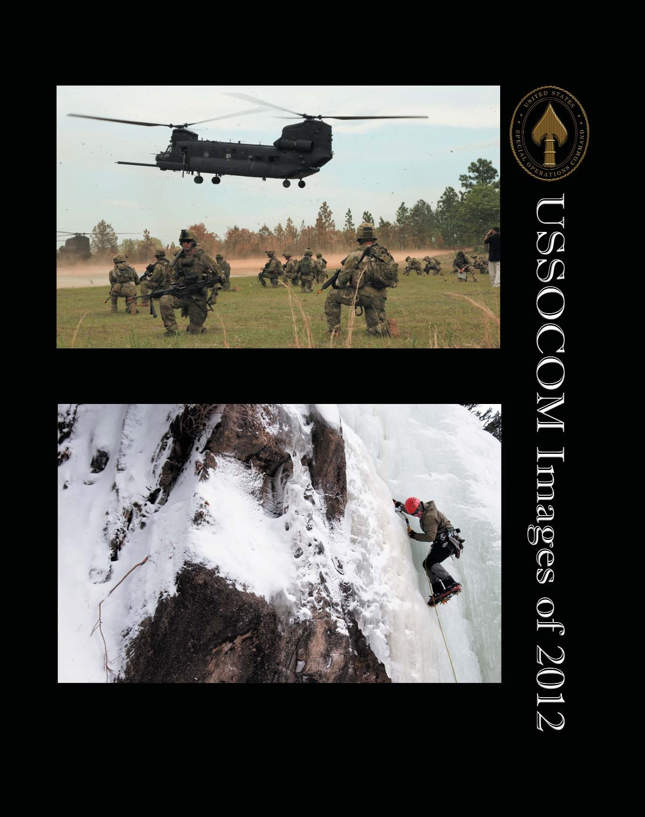

United States Army Special Operations Soldiers participate in a capabilities exercise, April 26. USASOC
courtesy photo.

A Special Forces Master Mountaineering Course instructor climbs an icy cliff using picks and crampons in order to demonstrate proper techniques for his students below, during a training exercise Feb. 22 at Rocky Mountain National Park in Estes Park, Colo. Photo by David Chace.

T i p o f t h e S p e a r
5

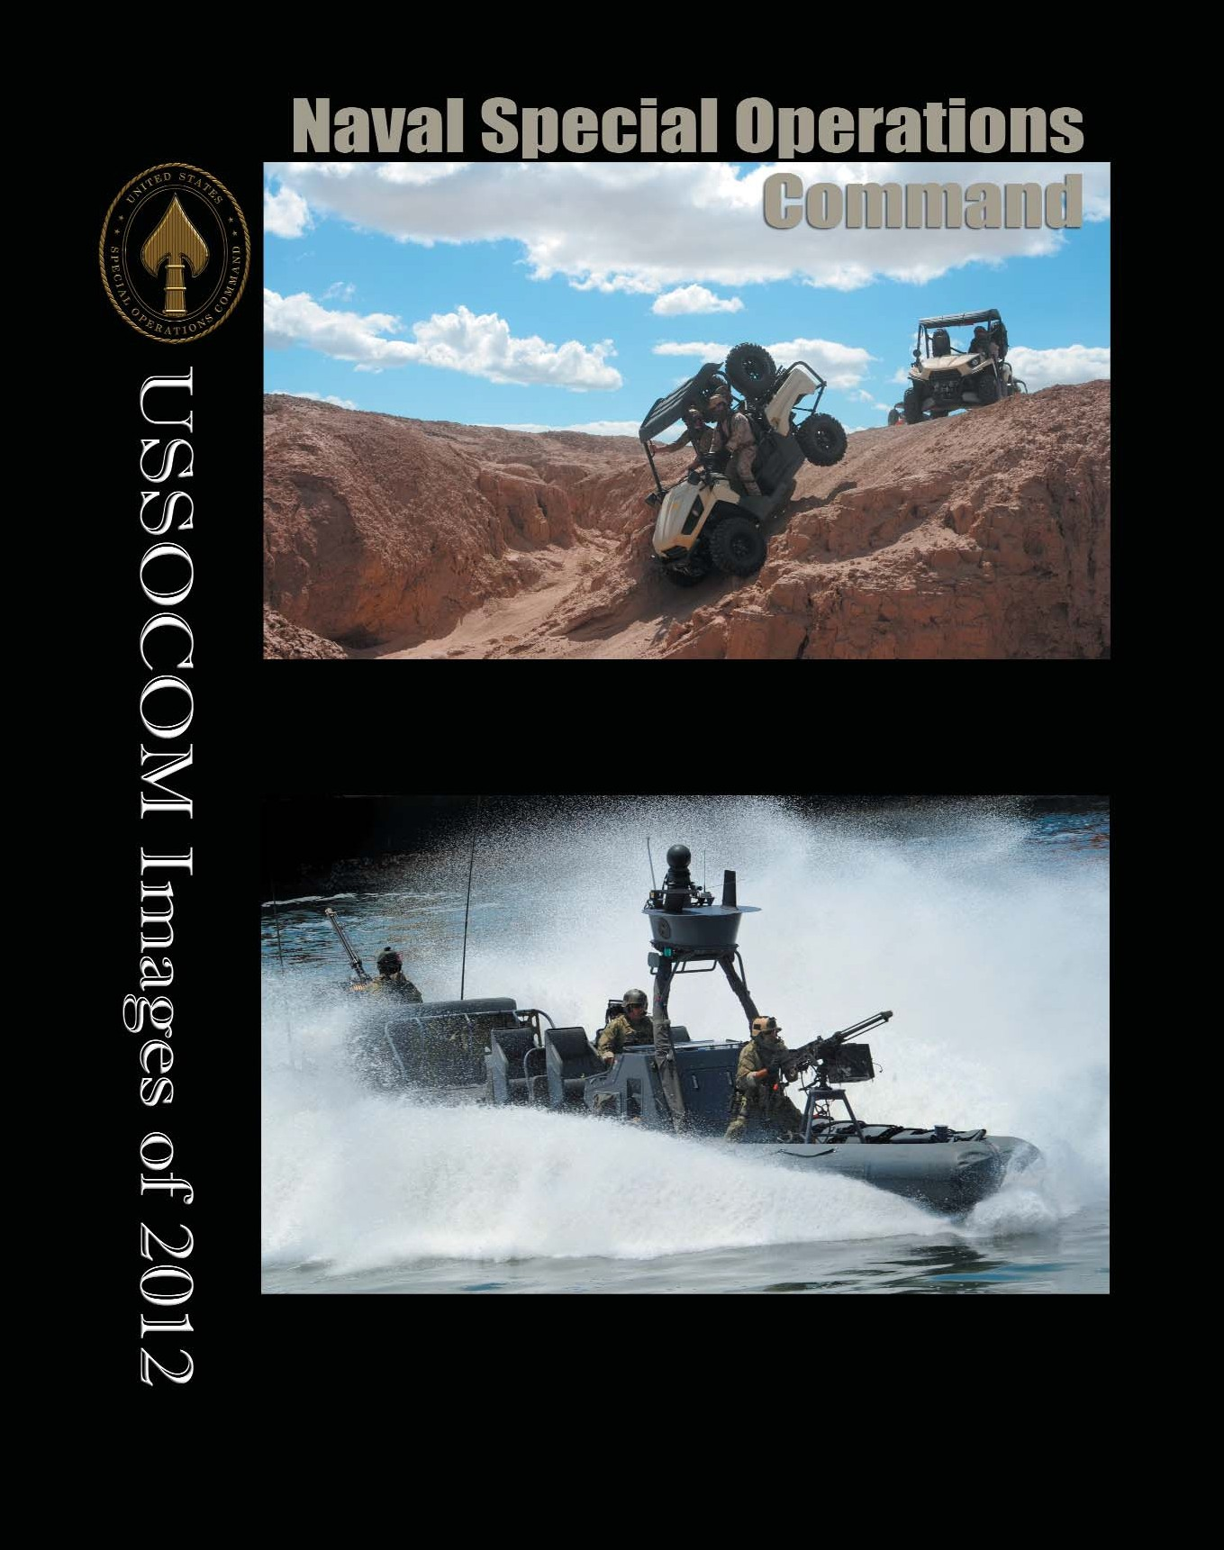

Light-weight tactical all terrain vehicle students get hands-on experience driving the vehicles in various environments and situations to prepare them for operations overseas. The LTATV is a Special Operations Command-funded program that provides SEALs with a new combat capability. Photo by Petty Officer 2nd Class Megan Anuci.

A Rigid-Hulled Inflatable Boat performs an assault in Tampa, Fla., May 23, during International
Special Operations Forces week. Photo by Air Force Master Sgt. Larry W. Carpenter Jr.

T i p o f t h e S p e a r
6

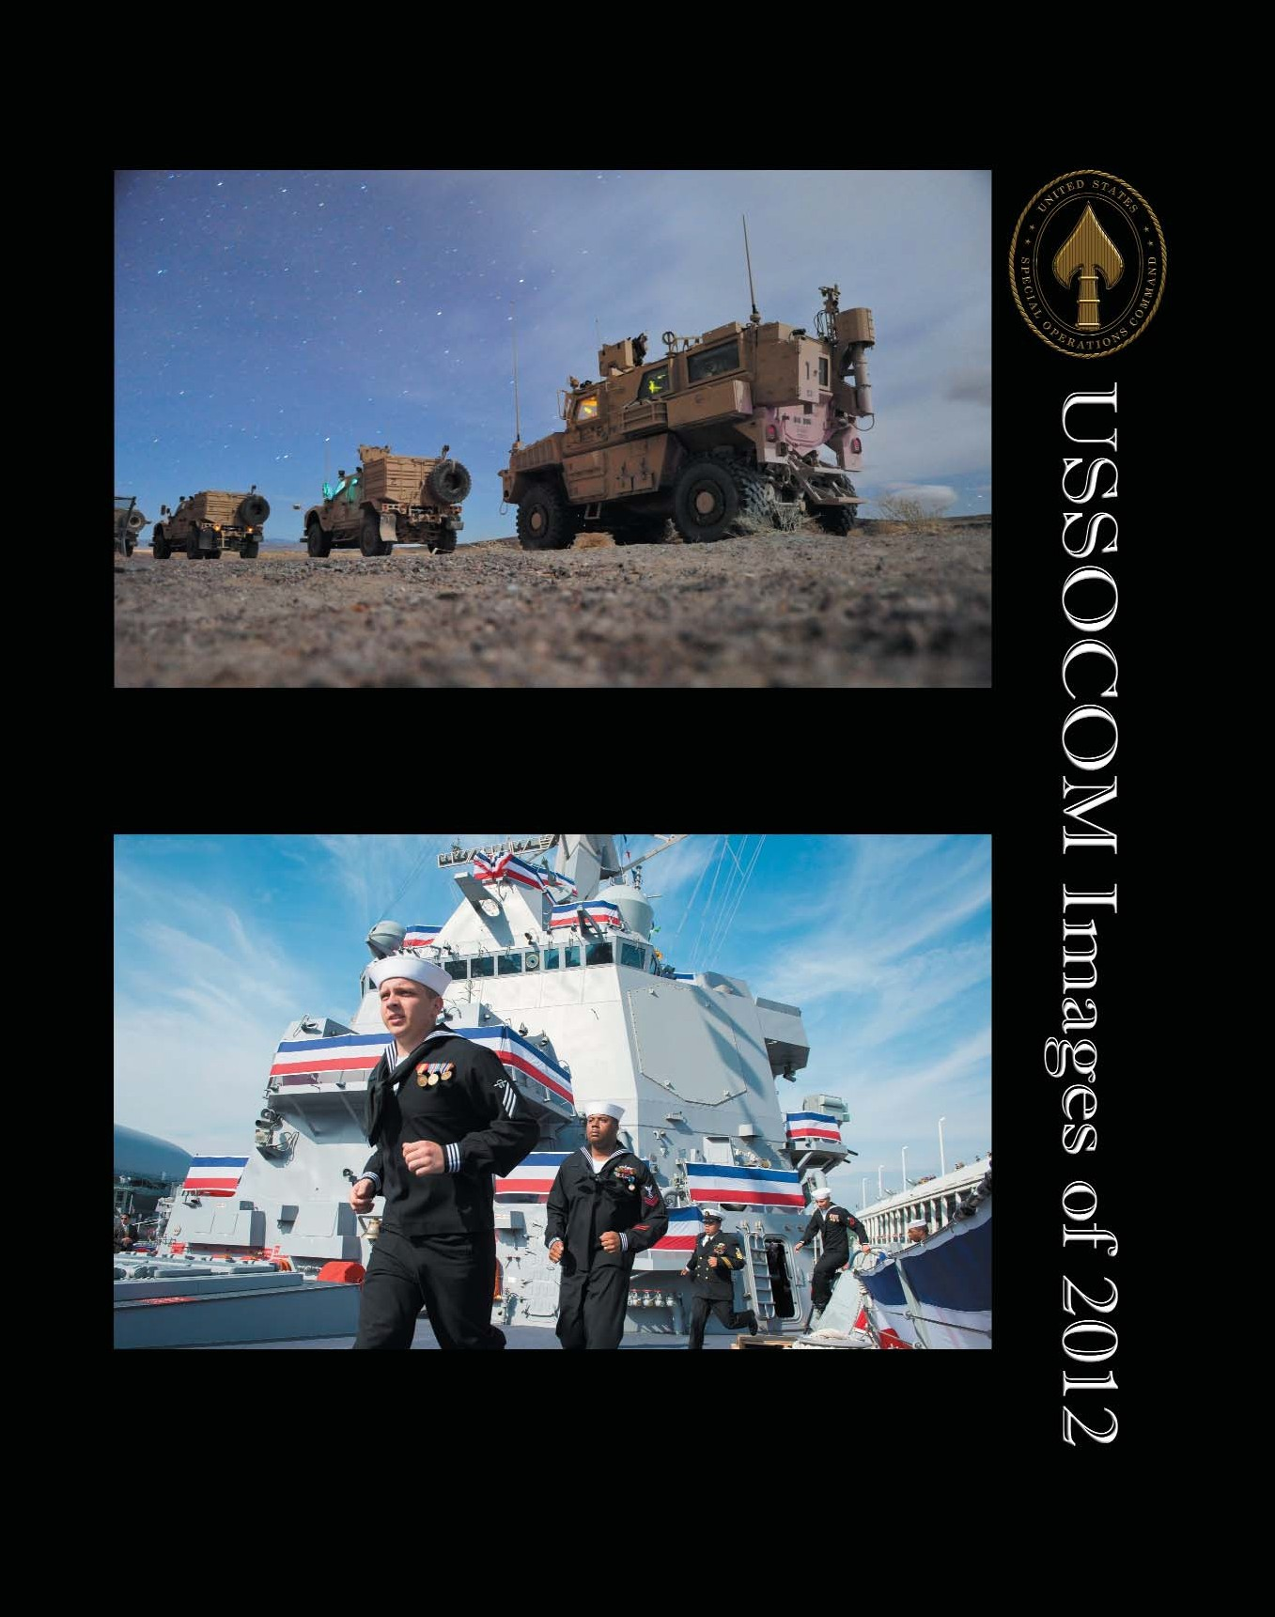

A squad of U.S. Navy SEALs participate in ground mobility training with Mine Resistant Ambush Protected Armored Vehicles March 28. The MRAP is used for combat patrols and high-risk missions. Photo by Petty Officer 2nd Class Meranda Keller.

The ship's officers and crew man the ship during the commissioning ceremony of the Arleigh-Burke class destroyer USS Michael Murphy (DDG 112), in New York City, Oct. 6. Murphy is named after Lt. Michael Murphy, a Navy SEAL and Medal of Honor recipient who posthumously received the nation's highest military honor for bravery during combat in Afghanistan in 2005. Photo by Petty Officer 1st Class Peter D. Lawlor.

T i p o f t h e S p e a r
7

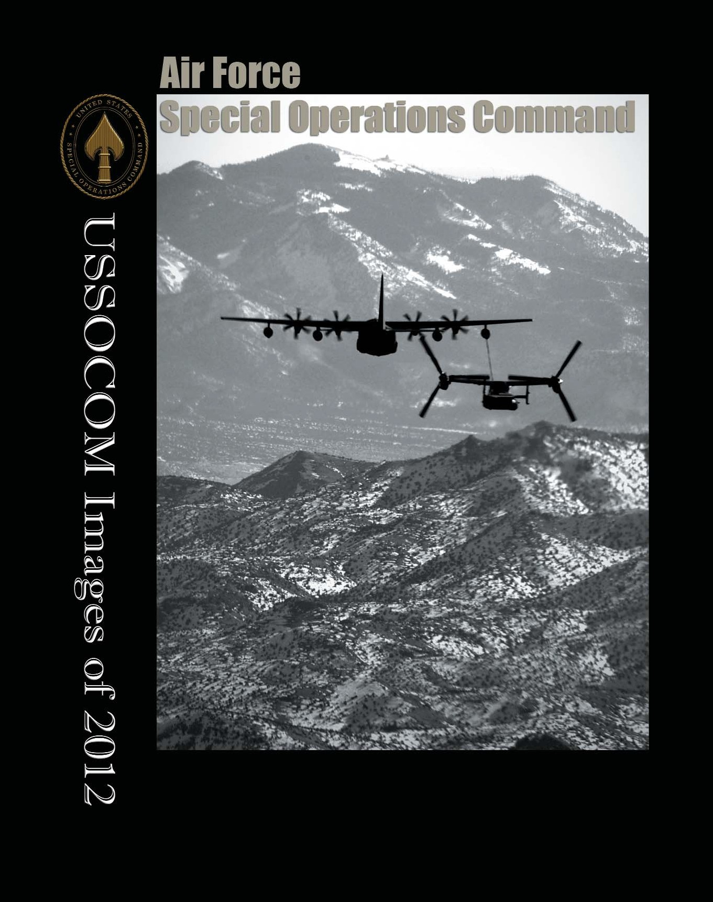

A 71st Special Operations Squadron, CV-22 Osprey, is refueled by a 522nd Special Operations Squadron MC-130J Combat Shadow II in the skies of New Mexico, Jan. 4. The 71st is stationed at Kirtland Air Force Base, N.M., and the 522nd SOS at Cannon Air Force Base, N.M. Photo by Senior Airman James Bell.

T i p o f t h e S p e a r
8

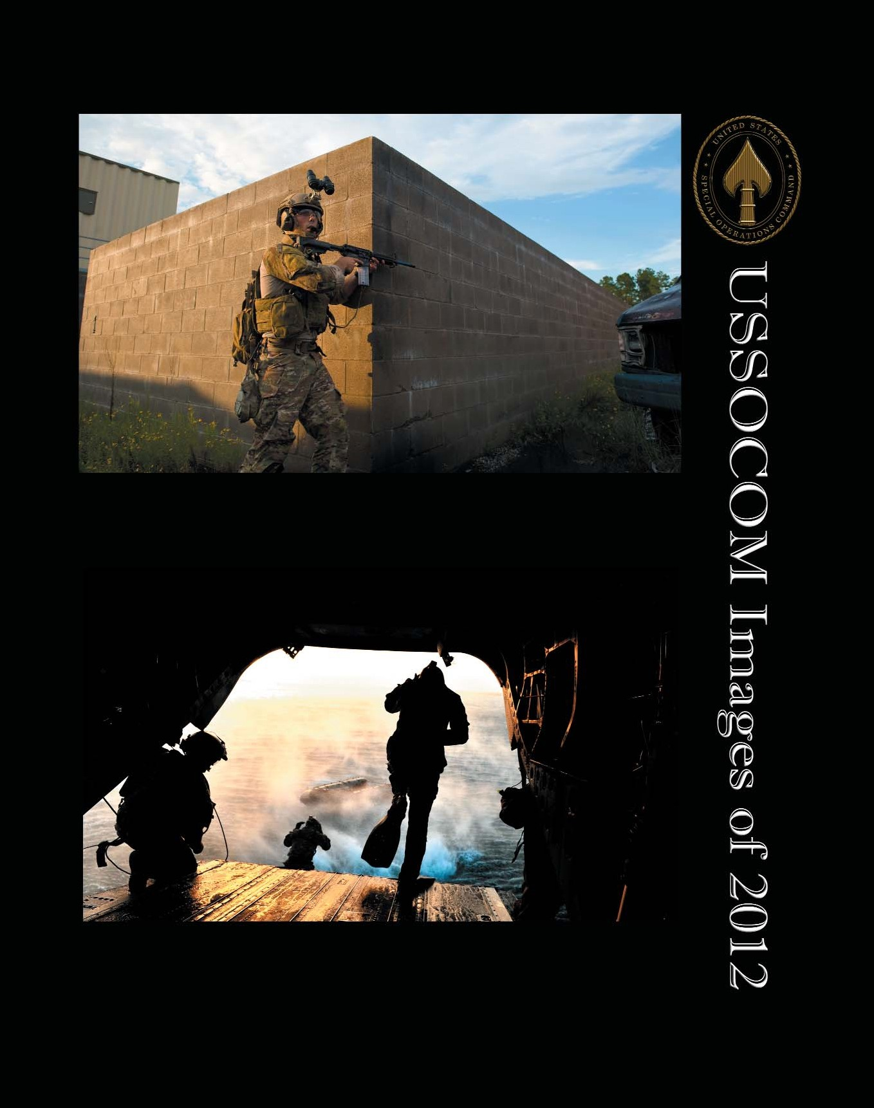

A U.S. Air Force pararescueman provides rear cover for an extraction team during an exercise on Eglin Range, Fla., Aug. 21. The pararescueman was participating in a scenario where his team had to respond to a simulated improvised explosive device explosion and transport the injured to safety. Photo by Air Force Staff Sgt. John Bainter.

U.S. Air Force Special Operations Weather Teams (SOWT) participate in a training scenario on a CH-47
Chinook during Emerald Warrior, Hurlburt Field, Fla., March 7. The primary purpose of Emerald Warrior is to exercise Special Operations components in urban and irregular warfare settings to support combatant commanders in theater campaigns. Photo by Air Force Staff Sgt. Clay Lancaster.

T i p o f t h e S p e a r
9

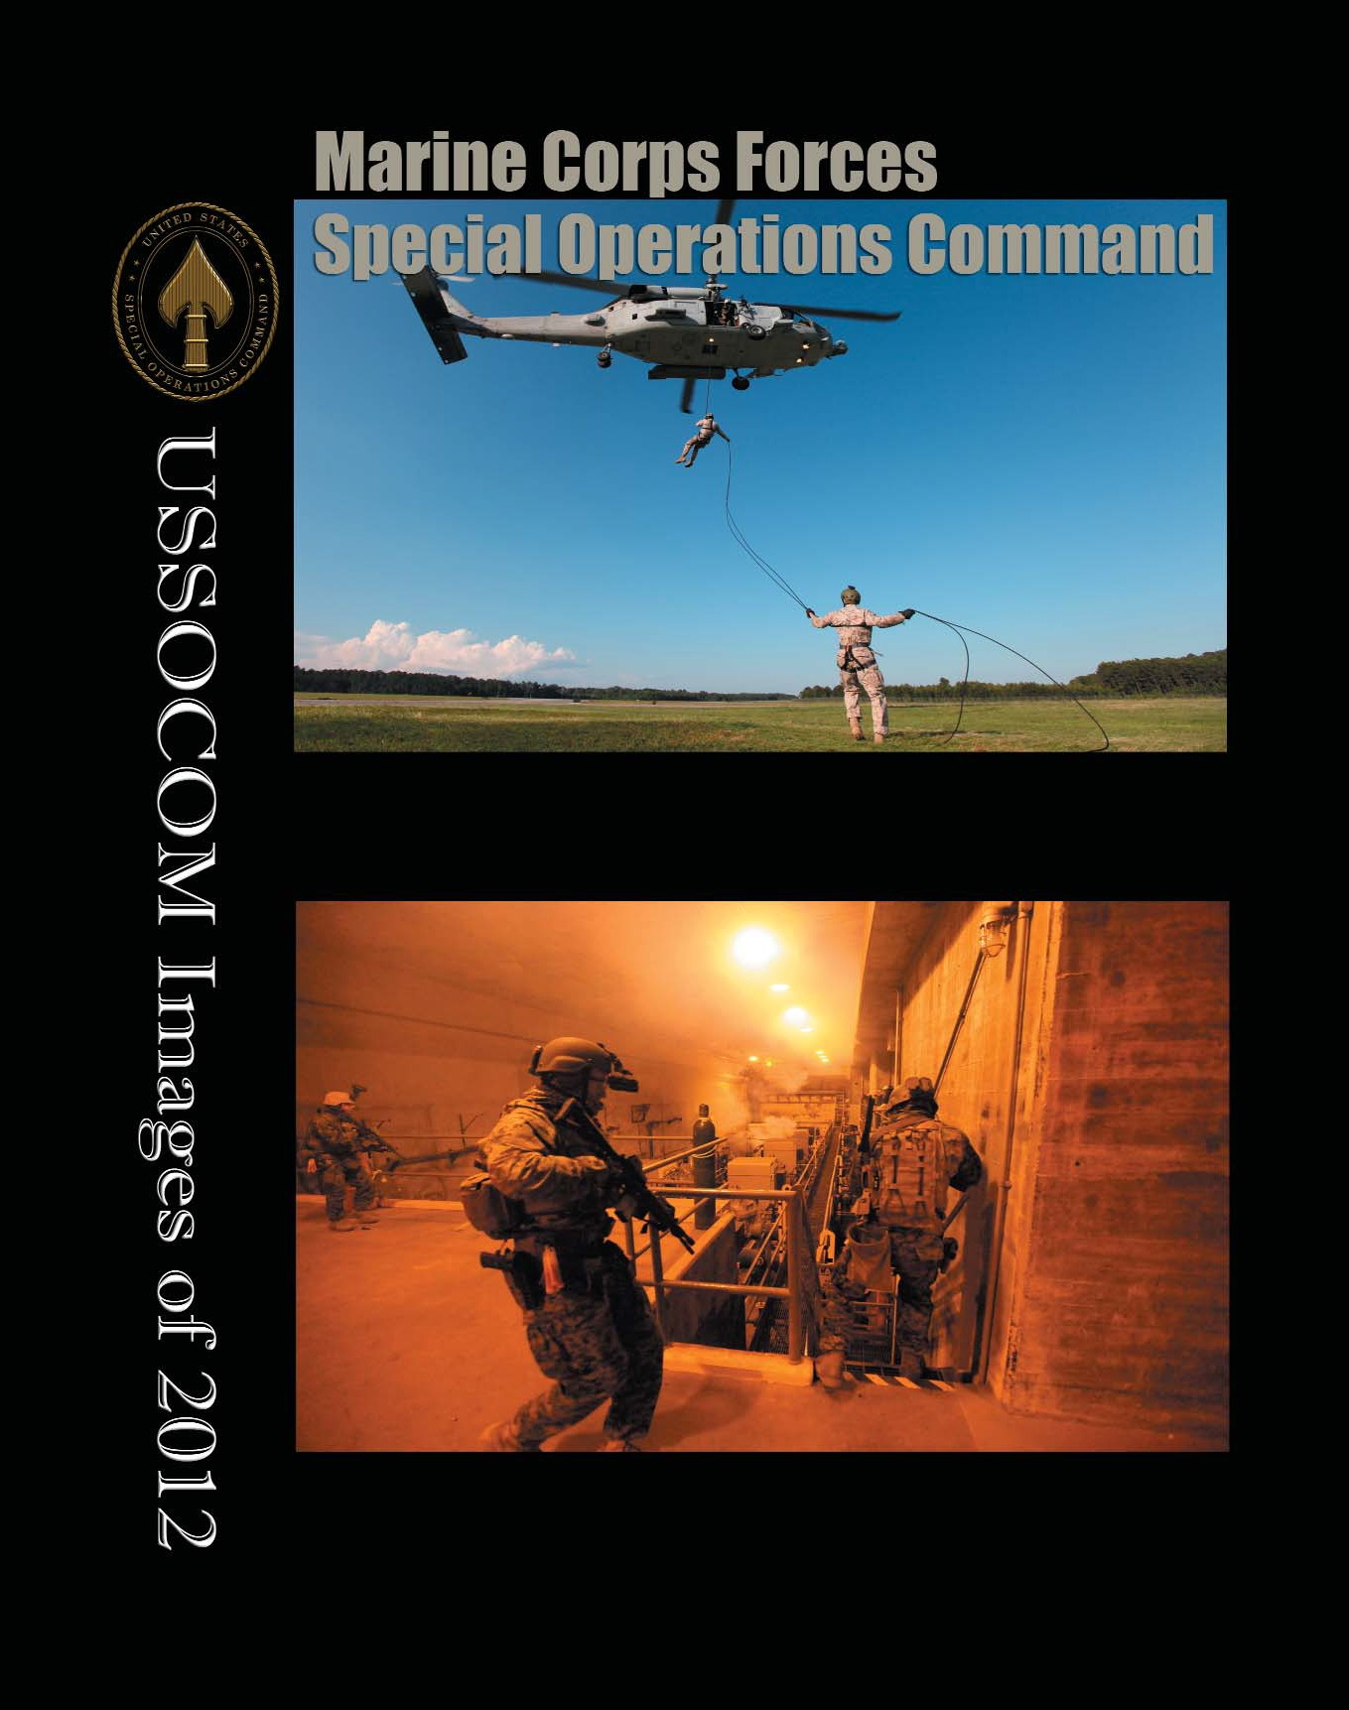

Marines with 3rd Marine Special Operations Battalion, U.S. Marine Corps Forces, Special Operations Command, practice helocasting drills in Savannah, Ga., May 23. Photo by Marine Corps Sgt. Anthony Carter.

Marines with 3rd Marine Special Operations Battalion, U.S. Marine Corps Forces, Special Operations Command, conduct predeployment training in South Carolina, May 22 - 24. Photo by Marine Corps Sgt. Anthony Carter.

T i p o f t h e S p e a r
10

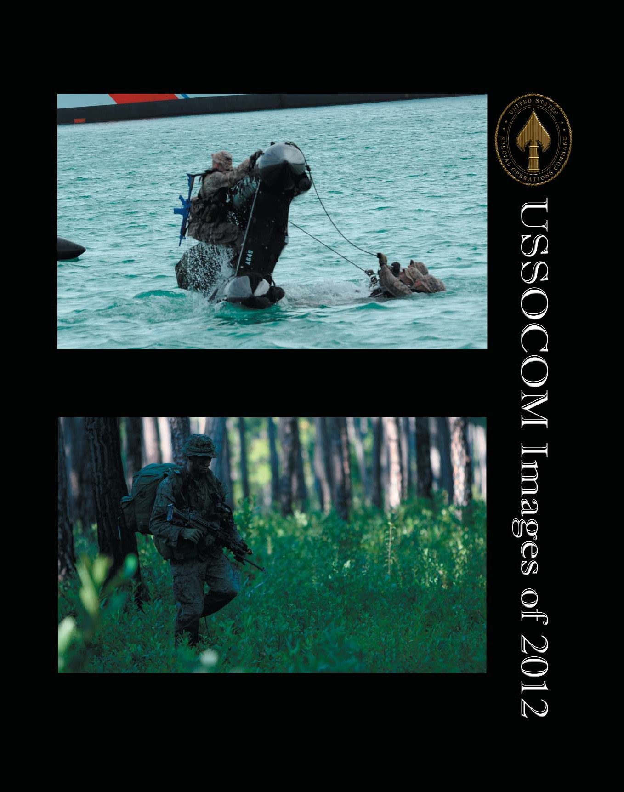

Marines participating in the Ranger Amphibious Assault Course in Key West, Fla., March 19 through 30, learn how to right a capsized Zodiac. The Zodiac is a rigid hull inflatable boat that the students must become proficient in quickly putting together, piloting and righting if capsized. This training is part of the Marine Corps Special Operations Individual Training Course, which all students must complete before becoming a Critical Skills Operator. Photo by Air Force Master Sgt. Larry W. Carpenter Jr.

A Marine attending the Individual Training Course patrols during the course's culminating exercise, Raider Spirit. Photo by Cpl. Thomas Provost.

T i p o f t h e S p e a r
11

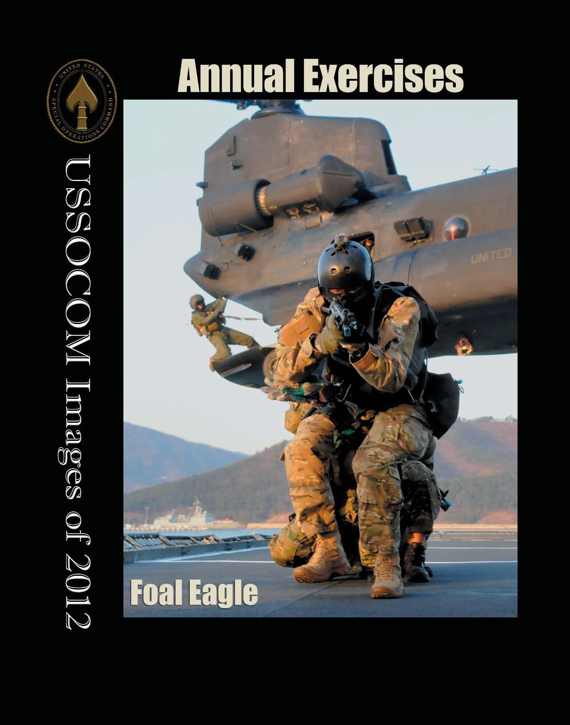

Republic of Korea Navy SEALs from the Korean Naval Special Warfare Brigade assault the aft deck of the AOE-59 Hwachun – a Korean naval refueling vessel – in Jinhae Harbor, Republic of Korea, March 20, as part of Foal Eagle 2012 - a multinational, joint-service exercise focusing on tactical-based warfare throughout the peninsula of Korea. Both U.S. and ROK Navy SEALs fast-roped out of a MH-47 Chinook helicopter prior to boarding and conducted visit, board, search and seizure training. Photo by Army Capt. Michael Odgers.

T i p o f t h e S p e a r
12

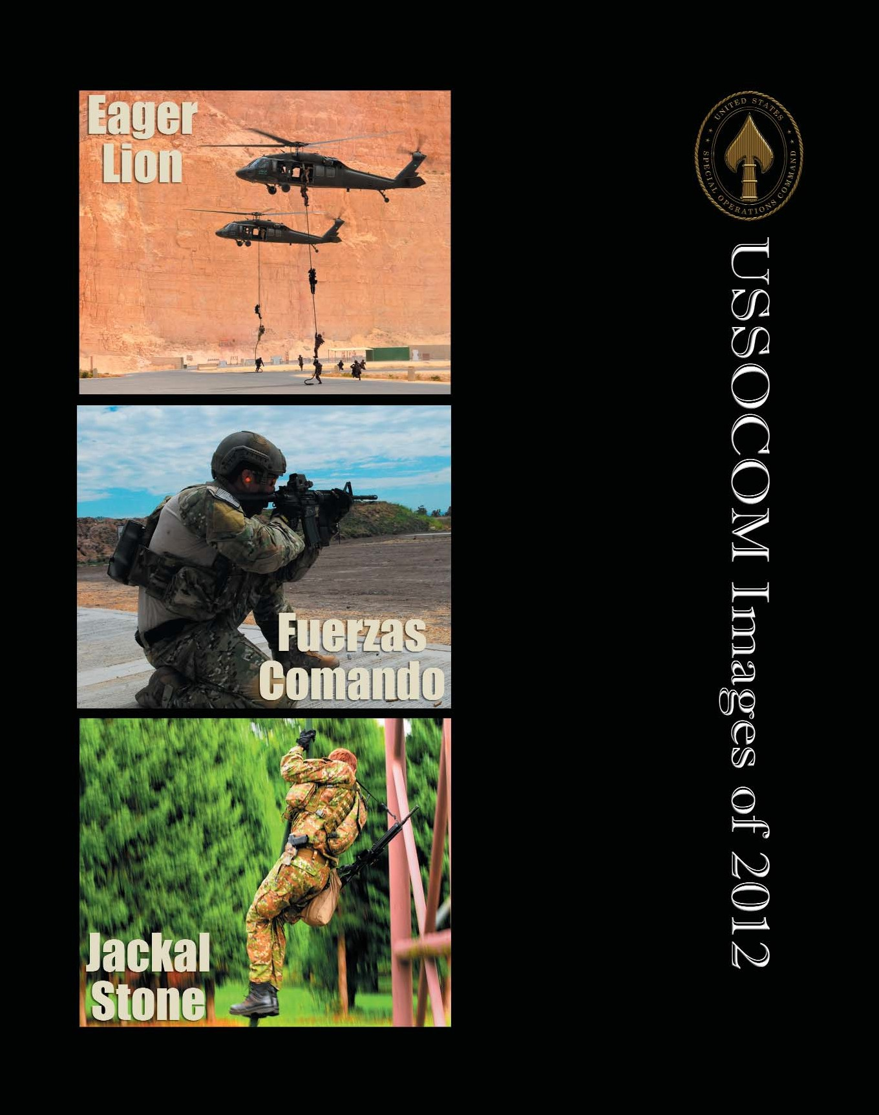Combined Joint Special Operations forces air assault onto a live-fire training objective during Exercise Eager Lion 12. Exercise Eager Lion is an irregular warfare themed exercise including 19 countries and more than
11,000 participants, focused on missions coalition partners might perform in support of contingency operations. Photo by Army Staff Sgt. Wynnfred Hoke.

A member of the U.S. Special Operations Forces competes in the rifle qualification event for Fuerzas Comando, June 7, at the Colombian National Training Center. Fuerzas Comando, established in 2004, is a U.S. Southern Command-sponsored Special Forces skills competition and senior leader seminar which is conducted annually. This event is aimed at enhancing training and strengthening regional and multinational cooperation, mutual trust, readiness and interoperability of Special Operations Forces in the region. Special Operations Command South serves as the U.S. execution agent for the exercise. Photo by Army Sgt. Karen Kozub.

A member of the Slovakian Armed Forces teaches fast-rope techniques in Delnice, Croatia, Sept. 14, during exercise Jackal Stone 2012. Jackal Stone is an annual joint Special Operations exercise designed to enhance capabilities and interoperability amongst the participating Special Operations Forces, as well as to build mutual respect while sharing various tactics, techniques and procedures. Photo by Senior Airman Jodi Martinez.

T i p o f t h e S p e a r
13

On June 12, Adm. Bill McRaven, commander of U.S. Special Operations Command, awarded the Distinguished Service Cross to Chief Warrant Officer Jason W. Myers (left) and Staff Sgt. Corey M. Calkins, (right) both assigned to 3rd Special Forces Group (Airborne). On March 27, 2010 Myers distinguished himself along a single lane road in the mountains of Afghanistan where his patrol was ambushed by an enemy force of approximately 75 to 100 insurgents. During this ambush Myers took command of the situation by directing movement, return fire and medical aid all while exposing himself to enemy machine guns and rocket propelled grenades. On Feb. 18, 2010 Calkins was part of a dismounted patrol consisting of U.S. Army, Marines and Afghan National Army Soldiers. During this patrol Calkins faced a formidable size enemy force in fortified positions. Facing this threat, Calkins assaulted his way through the area successfully suppressing the enemy force to allow the safe evacuation of three injured Marines. Photos by Army Staff Sgt. Marcus Butler.

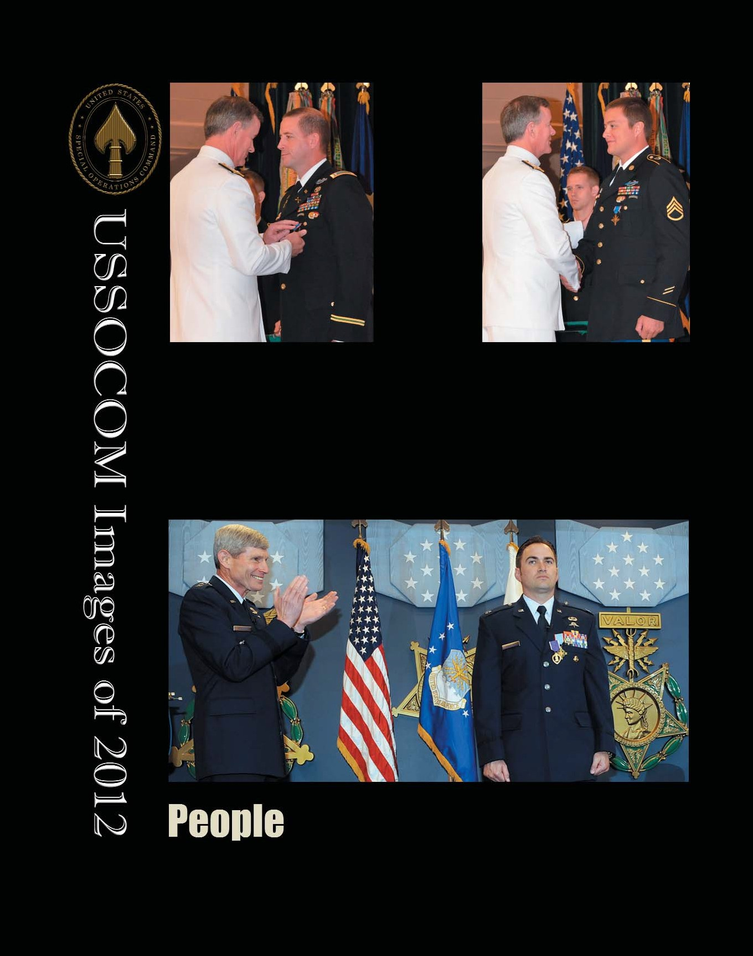

T i p o f t h e S p e a r
14
Former Air Force Chief of Staff Gen. Norton Schwartz, (left) congratulates Capt. Barry Crawford after he presented both the Air Force Cross and Purple Heart to Crawford in the Hall of Heroes, at the Pentagon, in Washington, D.C., on April 12. Crawford was awarded the Air Force Cross for his heroic actions controlling the air space and calling in airstrikes during a 2010 battle in Afghanistan, which allowed his Special Operations team to get out of the kill zone and ultimately saved the lives of his American and Afghan comrades. Photo by Andy Morataya.

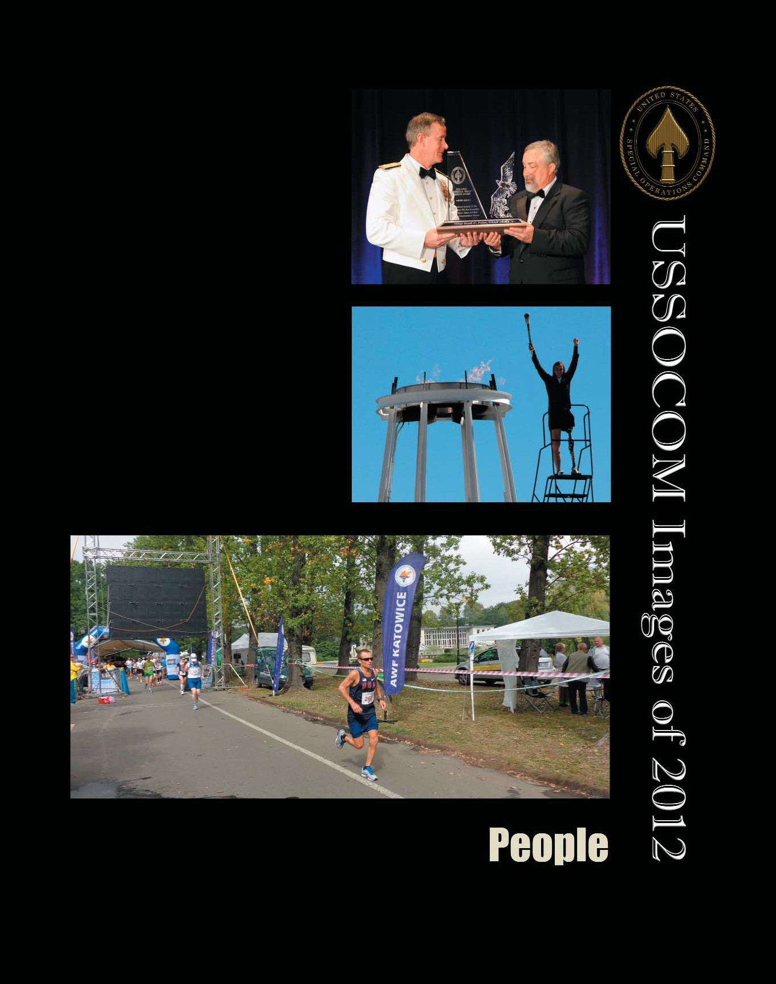

Adm. William H. McRaven, U.S. Special Operations Command commander, gives retired Air Force Master Sgt. Scott Fales USSOCOM's Bull Simons Award. This lifetime achievement award, named for Army Col. Arthur “Bull” Simons, honors the spirit, values, and skills of the unconventional warrior. Photo by Air Force Master Sgt. Larry W. Carpenter Jr.

Retired Army veteran Melissa Stockwell lights the cauldron at the Olympic Training Center in Colorado Springs, Colo., to officially kick off the
2012 Warrior Games. More than 200 wounded, ill or injured service members from the U.S. Air Force, Army, Navy, Marine Corps and Special Operations Command competed in the Olympic-style competition May 1-5. Photo by Tech. Sgt. Heather Kelly.

Army Master Sgt. Mike Morton, leads the pack of runners at the International Association of Ultrarunners 9th Annual 24 Hour World and 18th European Championships on Sept. 8 in Katowice, Poland. Morton, a U.S. Army Special Operations Command liaison officer, took first place and also broke the U.S.
24-hour record by running 172.457 miles. Courtesy photo.

T i p o f t h e S p e a r
15

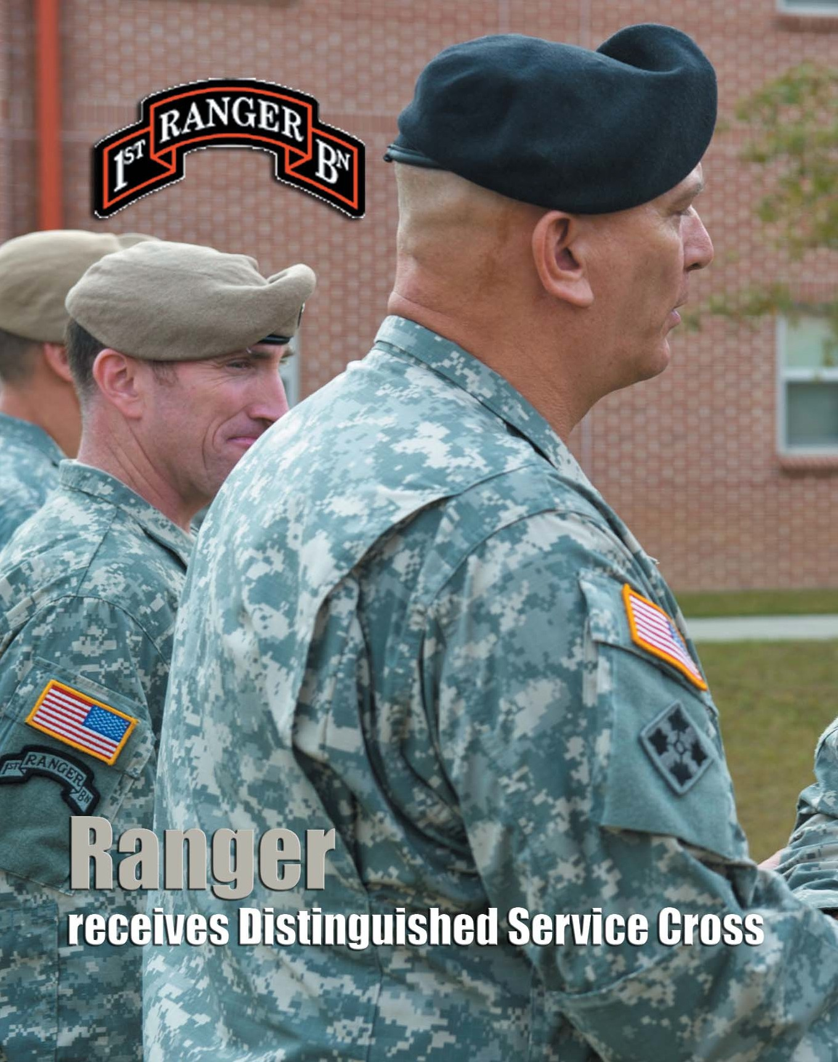

T i p o f t h e S p e a r
16

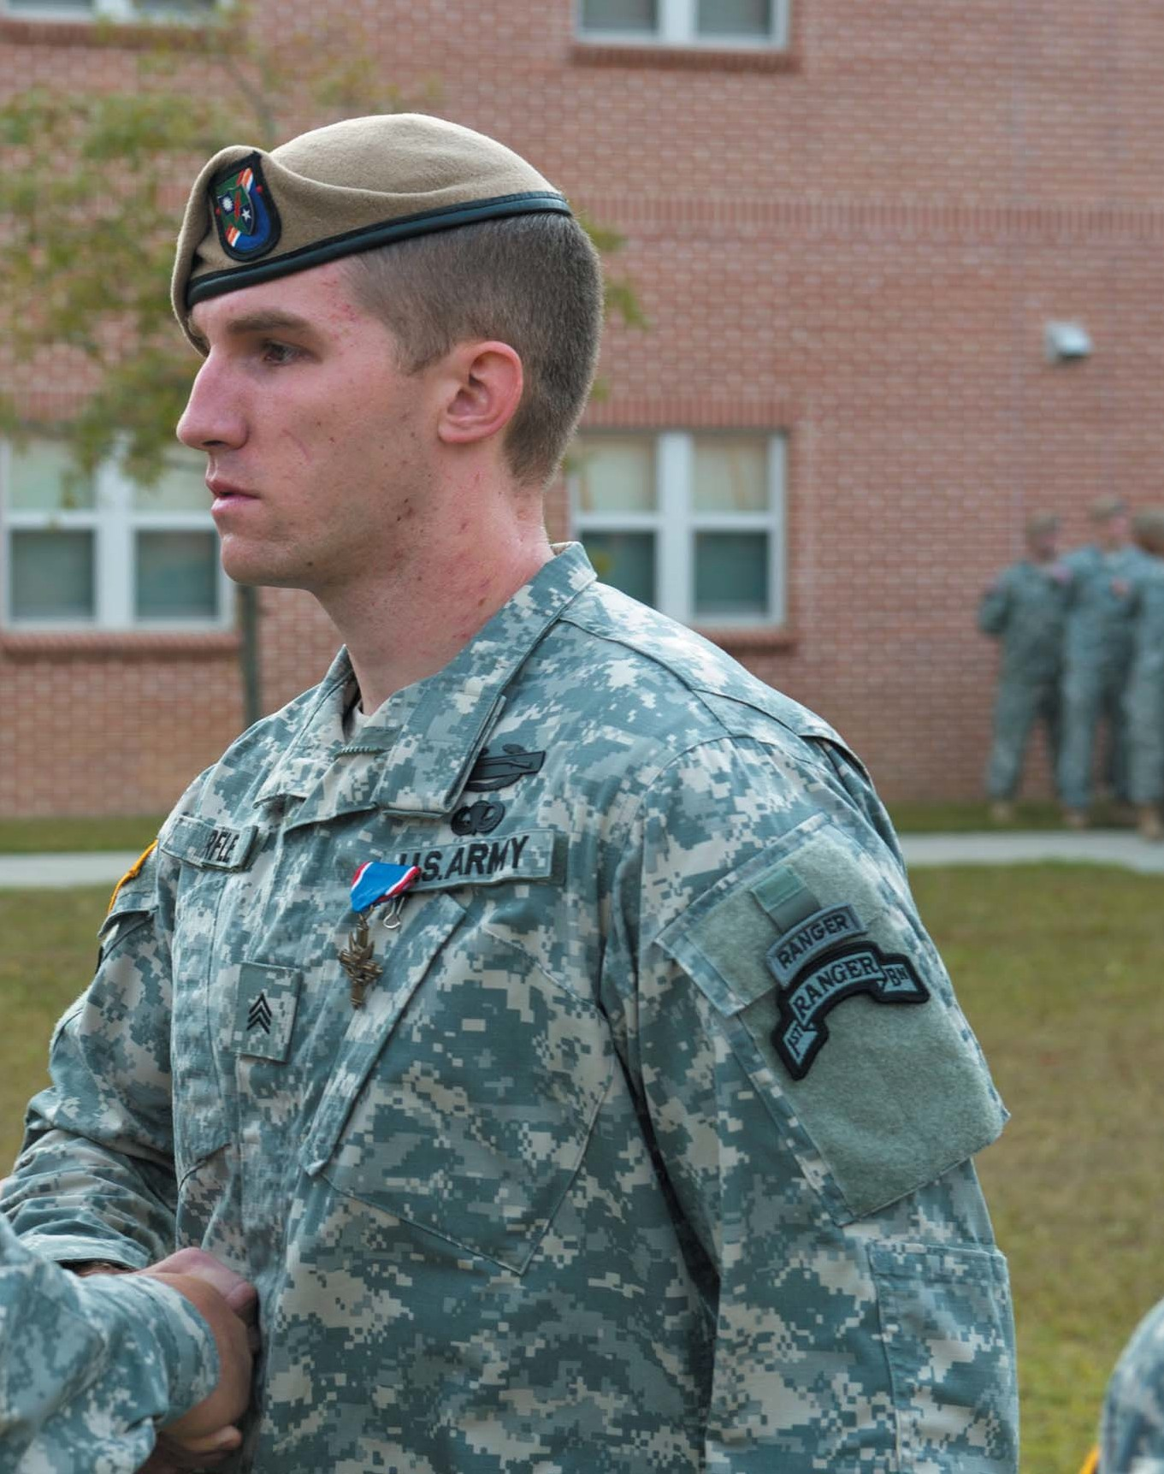U.S. Army Chief of Staff Gen. Ray Odierno presents the Distinguished Service Cross to Sgt. Craig Warfle, from Charlie Company, 1st Battalion, 75th Ranger Regiment, during an award ceremony at Hunter Army Airfield, Ga., Oct. 26. Warfle received the award for his actions during combat operations in Afghanistan. Photo by Army Staff Sgt. Teddy Wade.

T i p o f t h e S p e a r
17

Distinguished
Service Cross Citation for Specialist Craig D. Warfle

The following is the Distinguished Service Cross citation awarded to Specialist Craig D. Warfle.
Warfle has subsuquently been promoted to Sergeant.

The President of the United States
Takes Pleasure in Presenting
The Distinguished Service Cross
To
Craig D. Warfle
Specialist, U.S. Army
For Services as Set Forth in the Following

Specialist Craig D. Warfle distinguished himself by exceptionally valorous achievement as a Ranger Squad Automatic Weapons Gunner on August 18, 2010 while deployed to Afghanistan in support of Operation Enduring Freedom. Specialist Warfle was assigned to a task force, whose mission was to capture or kill Al Qaeda (AQ) and Taliban (TB) Senior Leadership.
Specialist Warfle’s valorous actions under effective fire while executing an objective saved the lives of his teammates and were instrumental in the death of at least 16 Taliban fighters, the removal of two Taliban Provincial Commanders, and the recovery of a large cache of weapons intended for use against Coalition Forces.
On August 18, 2010, the
team received special intelligence indicating that a

Taliban Commander and weapons facilitator, was meeting near a tree line with at least 17 other Taliban fighters. Information gathered indicated that the enemy was orchestrating an ambush on Coalition Forces in Logar Province, Afghanistan.
The team observed the fighters in position for the attack to include multiple spotters and runners used to communicate between the various fighting locations. The Battle Space Owner was notified of the imminent threat and diverted all convoys. When the enemy fighters aborted their attack they were observed
walking in a military formation back towards a meeting site along a tree line. Enroute to that location the enemy fighters were positively identified to be carrying weapons.
The team initiated a kinetic strike on the fighter’s location from two AH-64s. The team stood ready and boarded two CH-47 helicopters for insertion once the kinetic strike was complete.
Immediately after the kinetic strike, the team inserted a Ranger Element onto

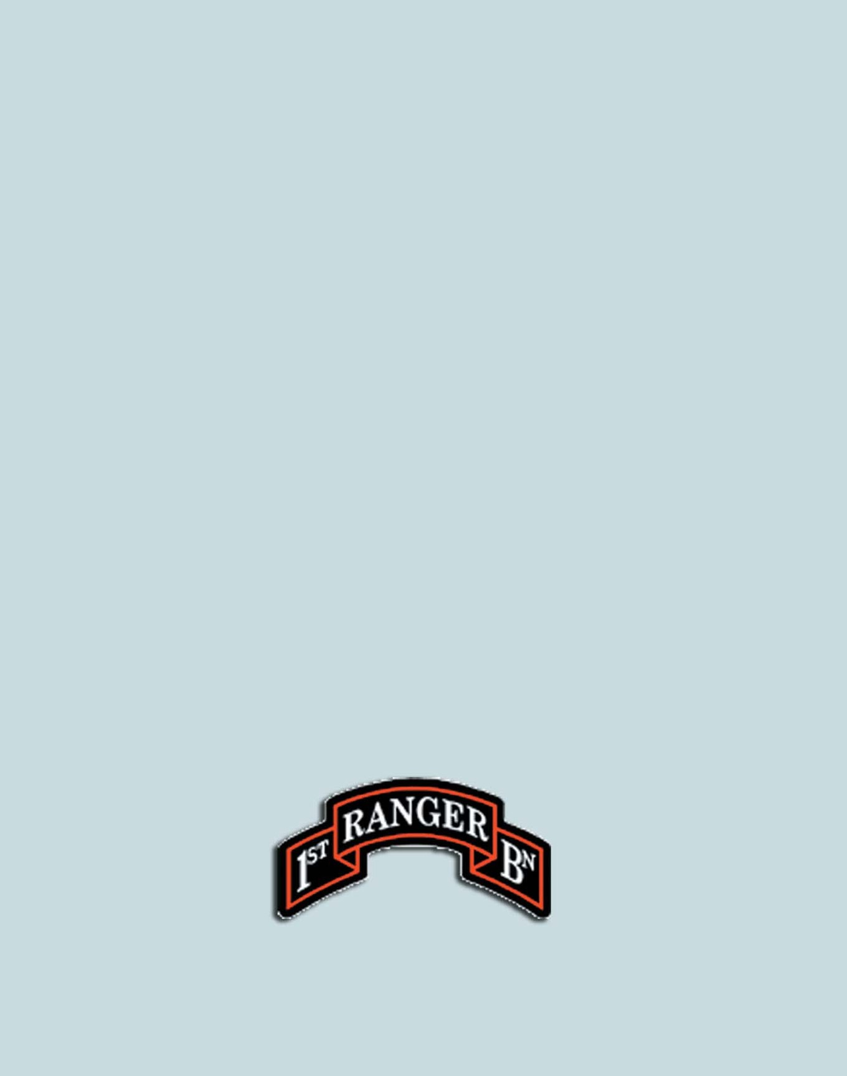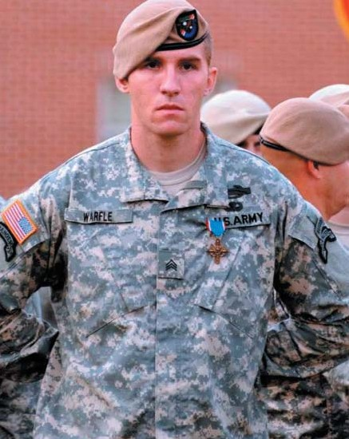

T i p o f t h e S p e a r
18

the hot landing zone to the West of the target area to eliminate the several remaining enemy combatants.
Ranger Element 1, consisting of Specialist Warfle and five others, were tasked with isolating the Northern side of the tree line and suppressing the enemy to allow Ranger Element 2 to assault from West to East.
Upon infiltration, the Ranger Assault Force received effective enemy fire in vicinity of the North-South running tree line where the AH-64s had just completed gun runs. As soon as Specialist Warfle stepped off the ramp he came under fire from multiple enemy positions and without hesitation returned fire and crawled 15 meters through the muddy field towards the enemy.
From this position, Specialist Warfle suppressed the multiple enemy positions with 150 rounds from his
MK-46 allowing Ranger Element 1 to move to the North and Ranger Element 2 to maneuver to the South. Under fire and with no cover in the open field, Specialist Warfle continued to suppress the enemy positions permitting
members of the Assault
Although Specialist Warfle knew he had been shot in the right shoulder he disregarded his own personal safety and moved through the kill zone to Sergeant Lugo’s side to protect his incapacitated Squad Leader. Specialist Warfle purposefully positioned himself in the line of enemy fire and immediately suppressed the enemy in order to defend Sergeant Lugo and provide covering fire for the platoon medic, Sergeant Solomon, to move to and treat Sergeant Lugo.
Specialist Warfle fearlessly continued to provide accurate suppressive fire from his exposed position, allowing Staff Sergeant Myers and Sergeant Kochli the ability to move forward, suppress the enemy, and then subsequently evacuate Sergeant Lugo.
Specialist Warfle continued to provide suppressive fire as Sergeant Solomon, Staff Sergeant Tucker, and Sergeant Kochli pulled Sergeant Lugo back to cover. Only after the casualty evacuation aircraft evacuated Sergeant Lugo did Specialist Warfle treat the through
and through gunshot wound
to his right shoulder by

Force to get down in the prone position while the leaders determined a way to assault the enemy positions.
After a couple of minutes passed, Ranger Element 2 came under heavy effective fire from enemy crew served weapons. Realizing that Ranger Element 2 was effectively pinned down in
— Specialist Warfle continued to provide
suppressive fire as Sergeant Solomon, Staff Sergeant Tucker, and Sergeant Kochli pulled Sergeant Lugo back to
cover. Only after the casualty evacuation aircraft evacuated Sergeant Lugo, did Specialist Warfle treat the through and through gunshot wound to his right shoulder by applying a tourniquet to his
right arm.
applying a tourniquet to his right arm.
Specialist Warfle then proceeded to engage the enemy position from a position between the enemy and the Platoon for over twenty minutes while the Assault Force
reconsolidated and moved back away from the enemy positions. He steadfastly

the open field to the South,
Specialist Warfle moved
remained at his forward
position delivering accurate

with Sergeant Lugo to the North to flank the enemy position from the North-West.
Specialist Warfle, while under heavy effective enemy fire, advanced on the enemy position to suppress the enemy and allow the Assault Force to maneuver on and destroy the entrenched enemy. As Sergeant Lugo and Specialist Warfle voluntarily maneuvered towards the enemy positions they identified two entrenched enemy personnel with automatic weapons firing on the Assault Force.
Specialist Warfle continued to advance on the entrenched enemy using suppressive fire alone to
protect Sergeant Lugo and himself because there was no available cover in open terrain. When Sergeant Lugo
and Specialist Warfle got within 25 meters of the enemy machine gun positions, Specialist Warfle and Sergeant Lugo were both hit with a volley of machine gun fire.
fire on the enemy until all members of the Assault Force had moved across the open field to cover 100 meters to the West.
Specialist Warfle bounded back to the West over the open field while the Assault Force provided suppressive fire. Specialist Warfle’s actions allowed the Assault Force to break contact, drop ordnance on the enemy positions, and safely move to the exfiltration hot
landing zone.
By repeatedly risking his life for others, Specialist Warfle’s purposeful gallant actions, selfless dedication to the safety of his teammates, and demonstrated extraordinary heroism were distinctive and exemplary. He is most deserving of the distinct recognition.
Through his distinctive accomplishments, Specialist Warfle’s personal actions reflect great credit upon himself, his unit, and the United States Army.



T i p o f t h e S p e a r
19

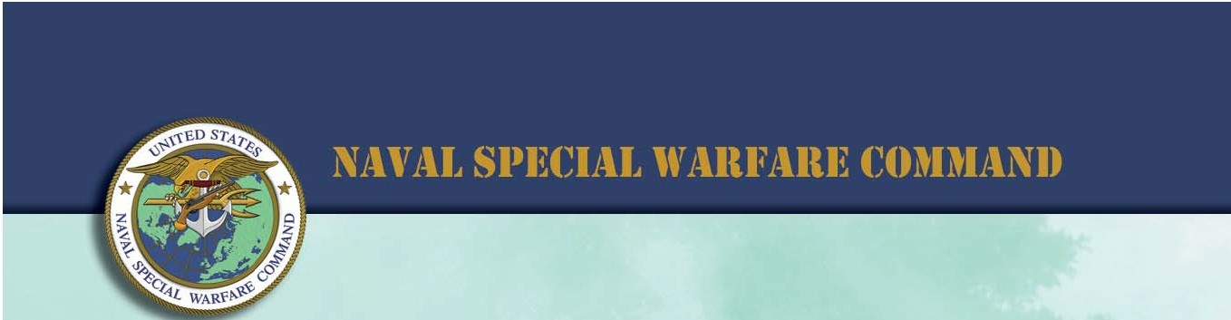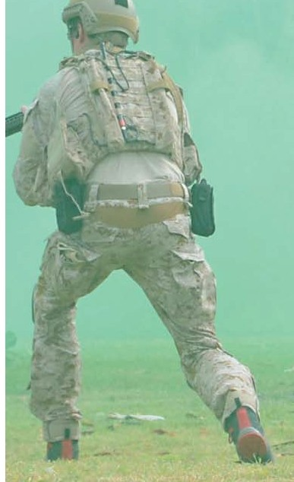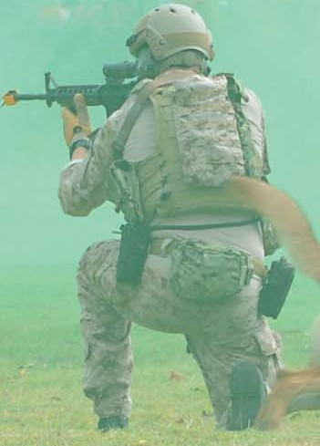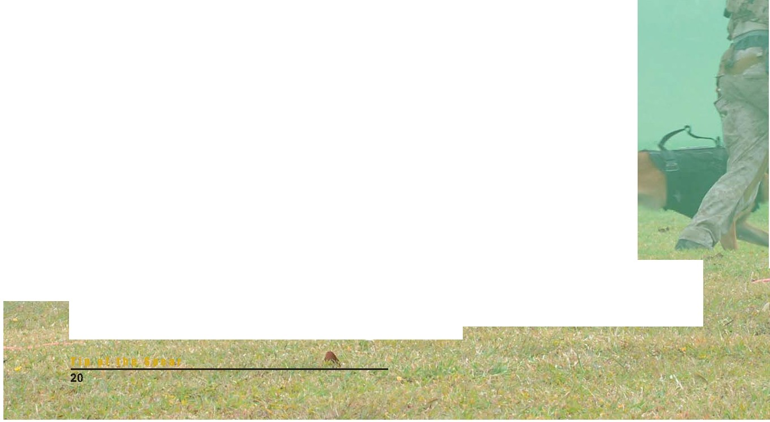

DDT-SEAl Museum
hosts 21th AnnualMuster

Members of an East Coast-based SEAL team demonstrate a mock assault during a capabilities demonstration at the National UDT-SEAL Museum in Fort Pierce, Fla. on Nov.10. The demonstration was part of the 27th Annual Muster and is held to raise awareness of the Naval Special Warfare community and as a reunion for veterans of the Scouts and Raiders, Underwater Demolition and SEAL teams. Photo by Petty Officer 2nd Class Leslie N. Long.

By Petty Officer 3rd Class James Ginther
Naval Special Warfare Group TWO

The National UDT-SEAL museum in Fort Pierce, Fla., hosted the 27th Annual Muster honoring former and current Underwater Demolition Teams and Navy SEAL operators, Nov. 11-12.
More than 10,000 people attended the two-day event which featured a capabilities demonstration by an East Coast-based SEAL Team and guest speakers including Adm. William H. McRaven, Commander, U.S. Special Operations Command; U.S. Representative Allen West; and retired
Navy SEAL Medal of Honor recipients
Michael Thornton and Thomas Norris.
The capabilities demonstration included a SEAL Team performing a helicopter assault, simulated sniper shot and the use
of a military working dog. The U.S. Navy SEAL Parachute team, the “Leap Frogs,” were also part of the demonstration and performed various aerial displays.
Tommy Norris, a former Navy SEAL, described the difficulties that the original UDT and SEAL teams faced during the Vietnam conflict.
“Through the efforts and the heroic courage of the members of those two units, legends were born within the teams,” said Norris. “Some of those legends are in the audience with you today…they won’t tell you who they are, but the team members know and I’m humbled to be in their presence.”
The ashes of eight fallen SEALs were laid to rest during a dedication ceremony on the beach adjacent to the museum. Active duty SEALs swam the ashes out to sea.
year.
“Twenty-seven years have passed since this museum opened,” said McRaven. “Back then there was some angst and curiosity as to whether this relatively small facility could even survive.”
He said that in the same way that the museum has grown and flourished, the Navy SEAL teams have expanded.
He remarked that the SEALs performing the demonstration exemplified the qualities that warriors require.
“The author Henry Stanley Haskins once said ‘what lies before and behind us are tiny matters compared to what lies within us” said McRaven.

The museum also hosted a 5k run/walk on the beach next to the museum, a skeet shoot and a live auction.
McRaven said that the number of attendees had doubled since the previous
Active duty Navy SEALs carry the ashes of deceased Underwater Demolition and SEAL Team members during a ceremony hosted by the National UDT-SEAL Museum in Ft. Pierce, Fla., Nov. 11. Photo by Petty Officer 3rd Class James Ginther.

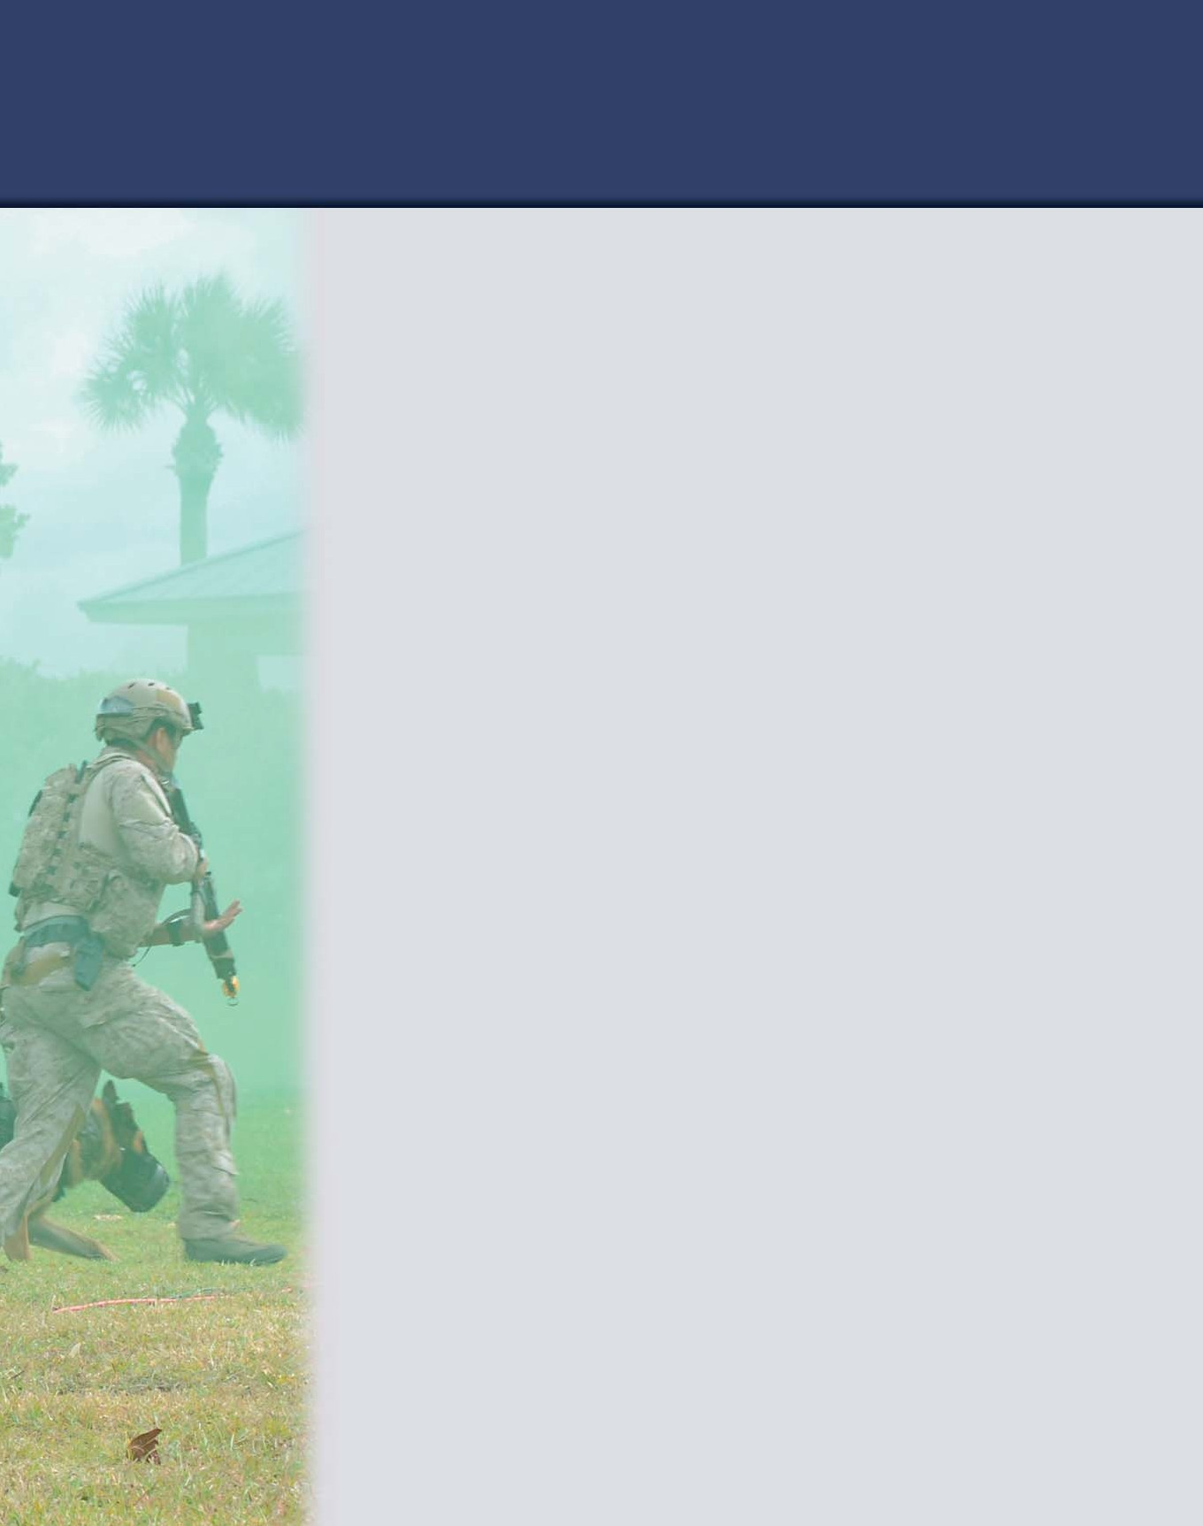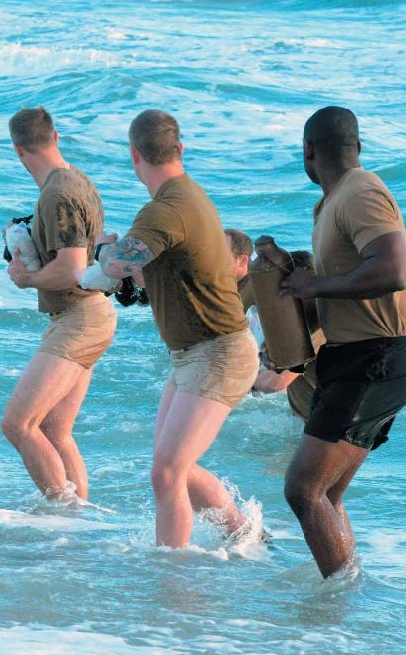

T i p o f t h e S p e a r
21

EOD tech earns
S i l v e r S t a r

By Airman 1st Class Hayden K. Hyatt
1st Special Operations Wing Public Affairs

An Air Commando from the 1st Special Operations Civil Engineer Squadron received a Silver Star during a ceremony at the Pentagon Nov.
14.

Tech. Sgt. Joseph Deslauriers, an explosive ordnance disposal technician, earned the medal for gallantry in action while serving in Afghanistan Sep. 23, 2011.
“You see this room filled with all these people and my family here,” Deslauriers said. “To hear ‘the most decorated EOD tech in the career field’—it’s
an honor for me to be here.”
According to the award’s citation, Deslauriers rendered one improvised explosive device inoperative and conducted a post-blast analysis of three subsequent detonations all within a four-hour time frame. After doing so, he then provided medical aid to an injured service member and used his detector to clear a safe path for the medical evacuation helicopter to land.
While clearing the area, Deslauriers stepped on an initiation system for an IED. Despite sustaining grave injuries, and as his teammates treated him
with aid, he continued to pass information about the

Col. James Slife, commander, 1st Special Operations Wing, presents the citation to accompany the Silver Star to Tech. Sgt. Joseph Deslauriers during a ceremony at the Pentagon on Nov. 14. The decoration is awarded for gallantry in military action against an enemy of the United States. Photo by Michael J. Pausic.

device that helped his team continue the mission. His actions led to the extraction of two injured Marines, two vehicles and completion of the mission.
Explosive Ordnance Disposal Airmen use their training to dispose of anything from roadside bombs to decommissioned missiles, all to save lives.
“We talked about honor, sacrifice, and courage,” the
triple amputee said. “But we don’t think about that stuff – we just do what we do, and we love it. I'd do it all over again.”
Deslauriers said he felt honored to be standing in the
Pentagon's Hall of Heroes, a place that honors the memory of hundreds of service members including Medal of Honor recipients.
“You belong here,” said retired Gen. Norton Schwartz, former Chief of Staff of the Air Force.
“Thank you, sir,” Deslauriers said. “To hear that from you is a great honor and from everybody here.”
The Silver Star is the third highest military decoration for valor and is given for gallantry in action against enemies of the United States.

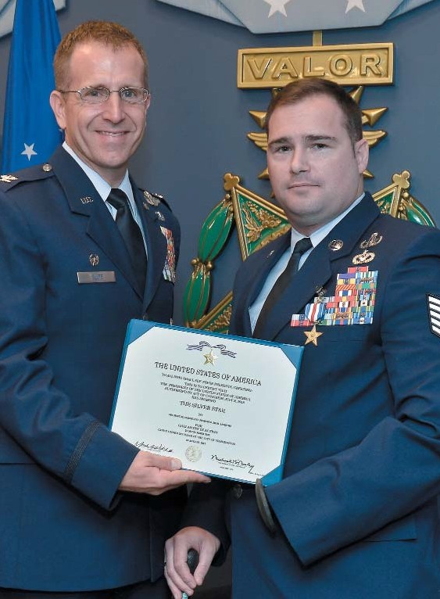

T i p o f t h e S p e a r
22

F o r m e r C S A F n o m i n a t e d
f o r T h e O r d e r o f t h e S w o r d
By Senior Airman Joe McFadden
1st Special Operations Wing Public Affairs

With no stars, bars, eagles or oak leafs among their multitude of stripes, the enlisted force of the Air Force Special Operations Command nominated their former Chief of Staff of the Air Force for his induction into The Order of the Sword at Hurlburt Field, Fla., Nov. 15.
Retired Gen. Norton Schwartz, accompanied by his wife, Suzie, accepted the nomination from Chief Master Sgt. Bill Turner, command chief of AFSOC, in front of more than 300 Air Commandos who lined the road along the distinguished visitor quarters' parking lot.
“We thank you for your 39 years of service,” Turner said. “For those 39 years, you and Mrs. Schwartz were our best teammates. You gave it your all and took great care of this force. And because of you, we are the Air Force that we are.”
The command chief then presented Schwartz, who served three tours at Hurlburt Field, a plaque bearing the nomination on behalf of the 11,000 enlisted men and women serving around the world under the AFSOC enterprise.
“We accept!” Schwartz said, to the applause of the crowd. “We remain an honorary chief here, so how sweet it is to close the book on this so many years later. Thank you very much.”
The retired general, who once served as commander of the current 1st Special Operations Wing, remarked on the continuing legacy of both AFSOC and the wing.
“It all started for us here in the fall of 1980,” Schwartz said. “For those of you who don’t think that amazing
things can happen in our Air Force, this is proof. You’re in a wonderful business. People know that if someone does bad things to America, this community will find them and make them pay. Do it professionally, do it discreetly, do it without fanfare -- you just do it. That’s what you're a part of -- all of you. It doesn’t matter what discipline -- everybody counts, especially in Special Operations.”
Schwartz will become the eighth inductee into
AFSOC’s Order, an honor based upon significant

Retired U.S. Air Force Gen. Norton Schwartz, former Chief of Staff of the Air Force, left, listens as Chief Master Sgt. Bill Turner, command chief of Air Force Special Operations Command, welcomes him back to Hurlburt Field while outside the distinguished visitors quarters at Hurlburt Field, Fla., Nov.
15. Turner then informed Schwartz of his nomination to be inducted into The Order of the Sword, the highest honor the enlisted corps can bestow upon an individual in recognition of significant contributions to the enlisted force. Photo by Airman 1st Class Christopher Williams.

contributions to the enlisted force.
“Thank you very much for this special treat for Suzie and me,” he said. “We envy you, we miss it already. So it will be fun to watch you continue to improve and continue to make the mark of Air Force Special Operations and the SOW – any time, any place.”
According to Air Force Instruction 36-2824, “The Order of the Sword was established by the Air Force to recognize and honor military senior officers, colonel and above, and civilian equivalents, for conspicuous and significant contributions to the welfare and prestige of the Air Force enlisted force, mission effectiveness as well as the overall military establishment.”
The AFSOC Order of the Sword induction ceremony
is slated for Feb. 1, 2013 at the Emerald Coast Conference
Center in Fort Walton Beach, Fla.

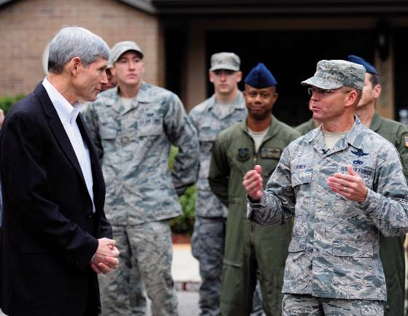

T i p o f t h e S p e a r
23

U.S. Air Force Special Operations Weather Teams participate in a training scenario on a CH-47 Chinook during Emerald Warrior, Hurlburt Field, Fla., March 7. Photo by Air Force Staff Sgt. Clay Lancaster.
Past, present Special Operations
Weather Teams shape elite career field

By Senior Airman Melanie Holochwost
AFSOC Public Affairs

The Special Operations Weather Team is one of the newest career fields in the Air Force, officially created just three years ago. However, this grey beret-wearing unit has been around since 1963, originally known as the Commando Combat Weather Team stationed at Hurlburt Field, Fla.
To remember their past and unique heritage, the Grey Beret Association was formed in May 2012 and recently named seven SOWT veterans to its hall of fame.
Selected for their outstanding service record were
Keith Grimes, Joseph Conaty Jr., Cornelius Gray,

Ronald Kellerman, Lloyd Mitchell Jr., Charles Irby, and
Henry Kelley.
These seven men laid the foundation for the SOWT
career field as it is known today.
According to Kelley, today’s SOWTs have gone through a drastically different process than he did as a member of the original team.
“At first, there was no selection process whatsoever,” Kelley said. “One day a colonel came up to me and said, ‘you look like you're in pretty good shape ... take the rest of the week off, you’re going to jump school on Monday.’”
As an airman second class, Col. (Ret) Wayne Golding said he made the team because he picked a piece of paper from a hat that read, “You are a

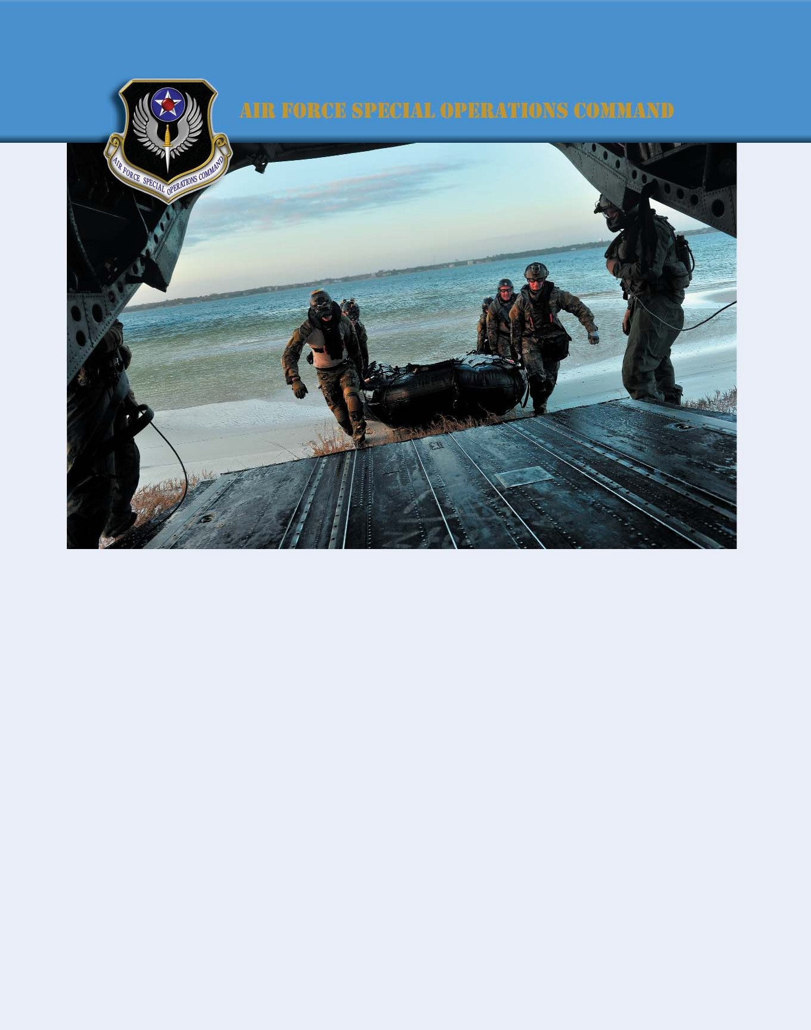
T i p o f t h e S p e a r
24

commando.” Then, just moments later he was selected as the acting NCO-in-charge because he wore the largest boots of the selectees.
Although these selection practices were pretty clever, the selectees were dropping left and right, mainly due to
a lack of mental strength and fortitude, according to
Golding.
“We definitely learned some things along the way,”
he said. “After we noticed how horrible our retention
rates were, we had potential recruits come to our unit and stay with us for about a week to sort of test them out and get to know their personalities. We made sure they were going to be alright. And, it seemed to work because we stopped losing people.”
Fast-forward about five decades, and the selection process is much more intense -- designed not to just retain, but to find the most elite warfighters.
Now, SOWT candidates must be able to swim 25- meters underwater twice, surface swim for 500-meters in less than 14 minutes, run 1.5 miles in less than 10 minutes and 10 seconds, and perform at least eight pull ups in a minute, 48 sit ups in two minutes, and 48 pushups in two minutes.
“That’s just the beginning,” said Maj. John Syc, 10th Combat Weather Squadron SOWT operations director. “After they begin training, they are expected to greatly improve on those numbers.”
Although the job has evolved over time, one constant between past and present is training. SOWTs have
always trained hard.
During the first few years, training was trial and error, Golding said.
“We didn’t have any good roadmaps for training when we started in 1963,” he said. “By 1964, we went through parachute training and survival school (now called Survival, Evasion, Resistance and Escape
training). We also trained on Morse Code, learned second languages and became experts in every weapon we
used.”
Since then, SOWTs have been steadily expanding on those training requirements.
“We now have a very structured training regimen that is scheduled several months in advance,” said Capt.
David Mack, 10th CWS SOWT. “Basically, when we are not deployed, our job is training.”
The training is about 70 percent weather-related and
30 percent tactical, according to Mack.
“It’s split up this way because if we are unable to do our jobs (as weathermen), we aren’t of much value to the mission,” he said. “But, the mission requires us to become ‘jacks of all trades.’ Not only do we need to know our primary jobs, but we also need to know
something about maintenance, logistics, and several other career fields, since we deploy in such small teams.”
Over the course of 50 years, the SOWT career field has adapted from casual beginnings to a very strict and structured present. SOWTs are selected from the best of the best and they train every day to ensure they are uniformly qualified for the dynamic demands of the mission.

A five-man Special Operations Weather Team participates in avalanche and environmental reconnaissance training. This type of training is usually completed in locations like Wyoming or Alaska, where they can hone their avalanche prediction skills. Courtesy photo.

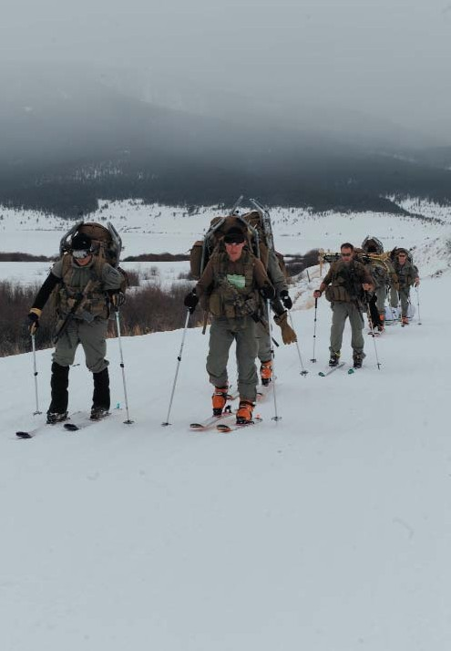
T i p o f t h e S p e a r
25

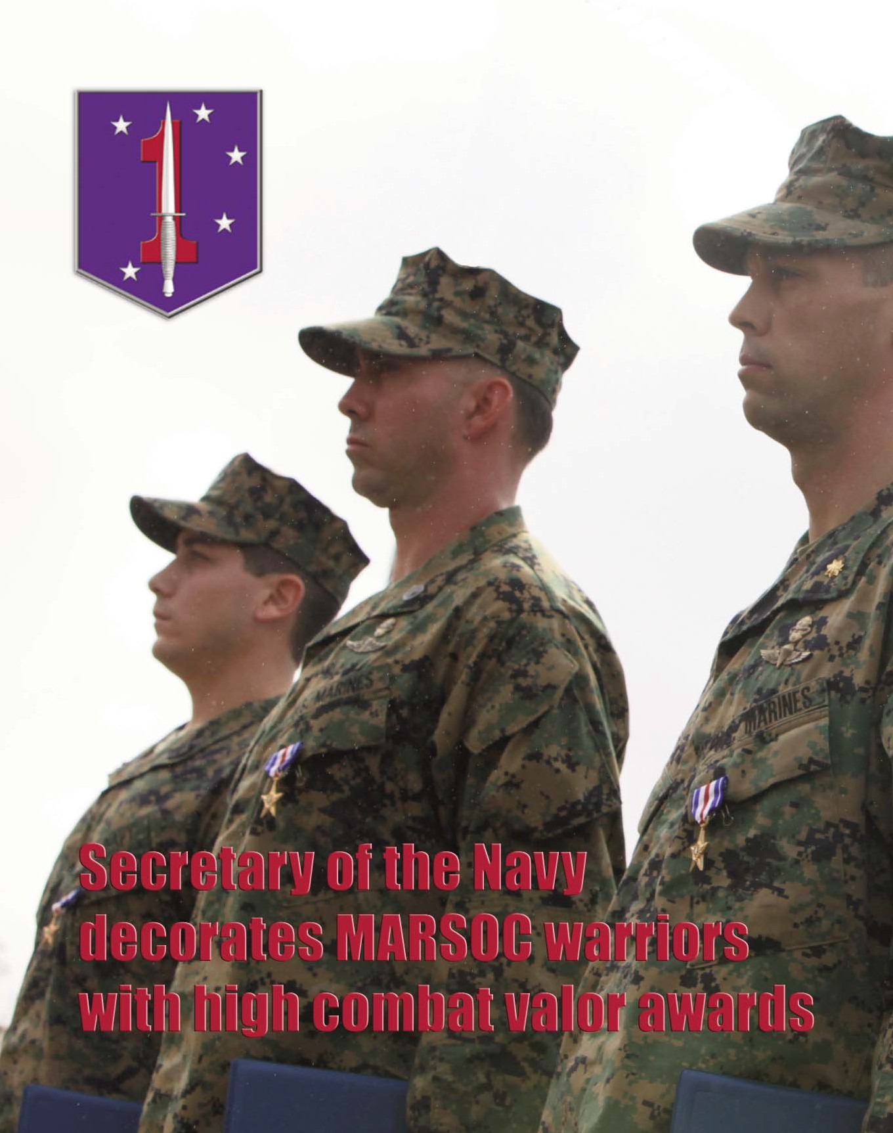

T i p o f t h e S p e a r
26

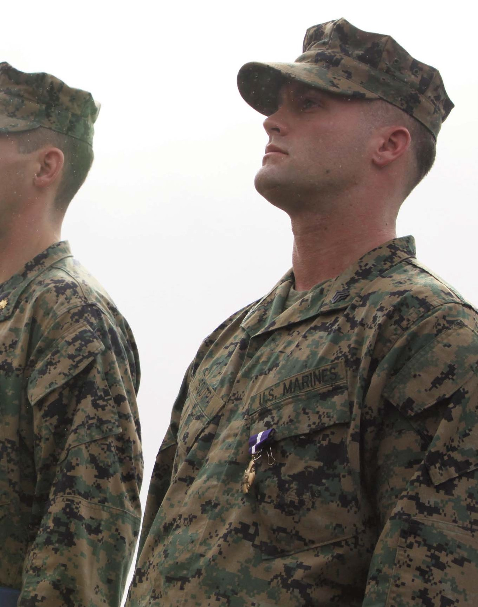

(From left to right) Petty Officer 1st Class Patrick B. Quill, Staff Sgt. Frankie J. Shinost, Maj. James T. Rose and Sgt. William B. Soutra Jr. of 1st Marine Special Operations Battalion, U.S. Marine Corps Forces, Special Operations Command, stand at attention after being awarded the nation's second and third highest awards for combat valor by Secretary of the Navy Ray Mabus at 1st MSOB headquarters aboard Camp Pendleton, Calif. Dec. 3. Soutra was awarded the Navy Cross, and Rose, Shinost and Quill were each awarded the Silver Star for extraordinary heroism exhibited during a combat mission in Helmand Province, Afghanistan nearly two years ago. Photo illustration by Marine Corps Cpl. Kyle McNally.

T i p o f t h e S p e a r
27

Sgt. William B. Soutra, Jr., was awarded a Navy Cross during a ceremony aboard Marine Corps Base Camp Pendleton, Calif., Dec. 3, for heroism while serving as a canine handler with Company B, 1st MSOB, in Helmand province, Afghanistan, during July 2010. Soutra’s unit was on patrol with Afghan commandos when his unit became pinned down by an ambush initiated by an improvised explosive device that mortally wounded his element leader. Soutra directed and oriented friendly fires while relaying enemy information, further enabling aircraft to provide suppression and coordinating casualty evacuations.

Story and photo by Marine Corps Cpl. Kyle McNally
MARSOC Public Affairs

In a rare public ceremony, four silent warriors from the
1st Marine Special Operations Battalion, U.S. Marine Corps Forces, Special Operations Command, were recognized with the nation’s second and third-highest awards for combat valor in a Dec. 3rd ceremony aboard Camp Pendleton, Calif.
Secretary of the Navy Ray Mabus and MARSOC

commander Maj. Gen. Mark A. Clark presented Sgt. William B. Soutra Jr. with the Navy Cross, and awarded the Silver Star to Maj. James T. Rose, Staff Sgt. Frankie J. Shinost and Hospital Corpsman 1st Class Patrick B. Quill for the extraordinary heroism they exhibited during a combat mission in Helmand Province, Afghanistan, nearly two years ago.
Then deployed with Company B, 1st MSOB, the
Marines and their Afghan Commando partners were tasked with a critical mission in the bloody district of Nahr-e

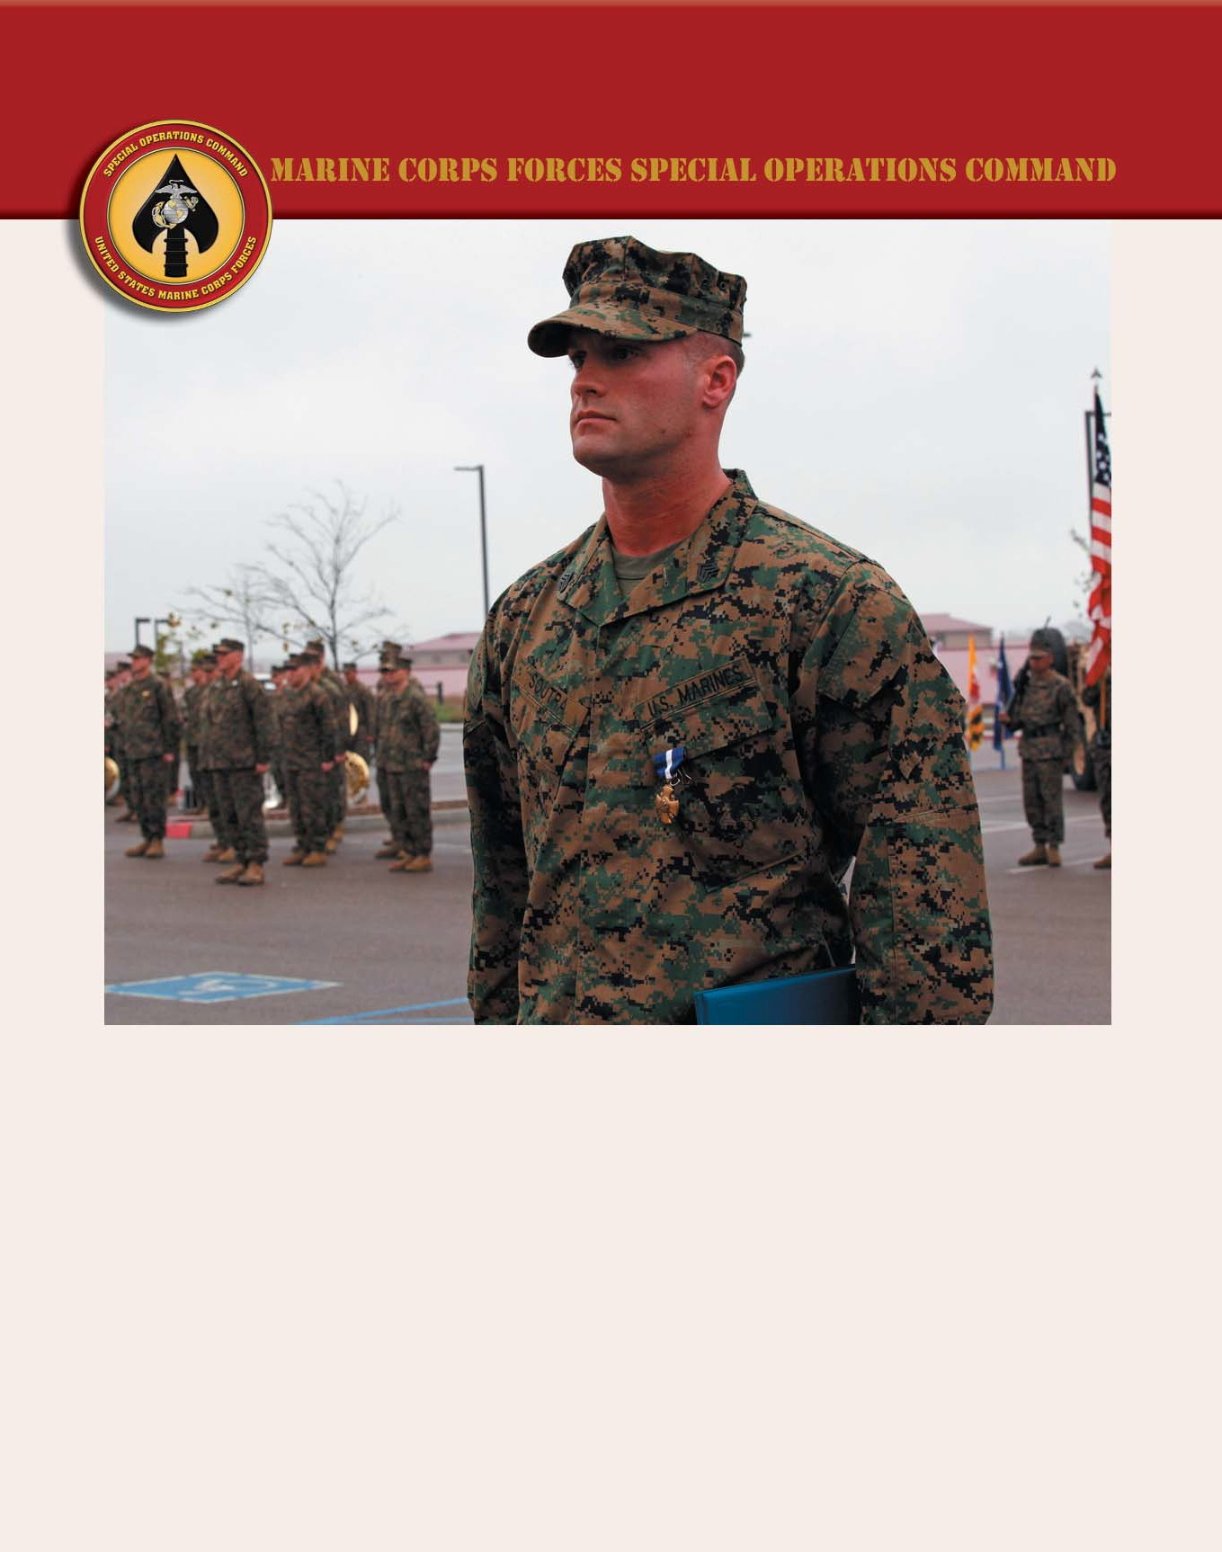
T i p o f t h e S p e a r
28

Saraj. Their objective was to capture an insurgent bomb factory and disrupt the enemy’s activity in the area.
After two days of brutal fighting, and with the patrol’s water and ammunition quickly diminishing, the violence culminated with an improvised explosive device blast that triggered an insurgent ambush and left element leader Staff Sgt. Chris Antonik mortally wounded.
According to Clark, the men he and Mabus recognized on a drizzly December morning at 1st MSOB’s headquarters
displayed “great heroism,
attack the enemy compound that was pinning down Soutra’s Commando platoon. The QRF, which included Shinost, the team’s Joint Terminal Attack Controller, charged through volleys of small arms fire directly at the enemy’s position. While engaging targets, Shinost managed to pinpoint an enemy position in the southern treeline, and directed a surgical A-10 airstrike that destroyed the threat.
With the enemy temporarily disoriented, Soutra and
Quill carried Antonik to safety. Rose and Shinost continued to engage the insurgents in the

extraordinary bravery and conspicuous gallantry” in the harrowing moments that followed.
Soutra, then a dog handler, and Quill, the team corpsman, received the distress call from Antonik as they were making their way back from another platoon’s position with a partial resupply of ammo. Before they could move further, their position erupted with flurries of insurgent machinegun and mortar fire. Pinned down, their Commando partner force
“This is a chance to recognize people
who don’t get recognized much. Most
of their missions are classified, most of the time we don’t hear anything about them or the extraordinary actions they take on a daily basis. And to be able to do this publicly, to recognize these
four extraordinary human beings…is very special for me, for the Marine Corps, for the Navy, and for the country.”

— Secretary of the Navy Ray Mabus
compound, who now
concentrated the majority of their fires on them. Rose stood fast, engaging targets less than 50 meters away. The fire was so intense that a bullet severed his rifle sling.
Shinost repeatedly exposed himself to the barrage, locking on targets for the A-10s and marking a drop zone for the MEDEVAC helicopter. Coordinating with Soutra to identify insurgent positions, Shinost directed his aircraft to silence the enemy guns for good

became disoriented.
According to his citation,
with a final airstrike.
After more than 48 hours of

Soutra then “immediately and boldly took charge.” “Moving exposed down the line,” he signaled the
Commandos to concentrate their fire on the enemy’s position, often physically maneuvering them to do so. With his platoon oriented, he and Quill then rushed into the kill zone to find Antonik.
After moving 150 meters through swarms of machinegun fire, they reached the blast site, where Antonik lay semi-conscious beside a wounded Commando. With rounds zipping past, Quill immediately went to work rendering lifesaving aid to Antonik, shielding him with his own body. Soutra applied tourniquets to the wounded Commando’s legs. After dragging him to a ditch for cover, Soutra returned to Quill, only to discover that Antonik could not be moved hastily due to his injuries. All three men
stayed in the kill zone, despite the intensifying enemy fire.
Rose was listening to the deteriorating situation on his radio. With the ambush site’s dense vegetation rendering air support impossible, Rose organized a quick reaction force to
sustained fighting, the Marines and the Commandos pulled out. They had destroyed the bomb factory, and had killed approximately 50 enemy fighters.
Antonik was posthumously awarded the Bronze Star with combat “V.”
According to their citations, Soutra, Rose, Shinost and Quill each “epitomized” their respective combat roles, and their actions saved the lives of their fellow Marines and Commandos. Additionally, SSgt. Bradley A. Harless, who is currently on deployment, will be presented a Bronze Star with V upon his return for his heroic actions during the same operation.
“This is a chance to recognize people who don’t get recognized much,” said Mabus. “Most of their missions are classified, most of the time we don’t hear anything about them or the extraordinary actions they take on a daily basis. And to be able to do this publicly, to recognize these four extraordinary human beings…is very special for me, for the Marine Corps, for the Navy, and for the country.”


T i p o f t h e S p e a r
29

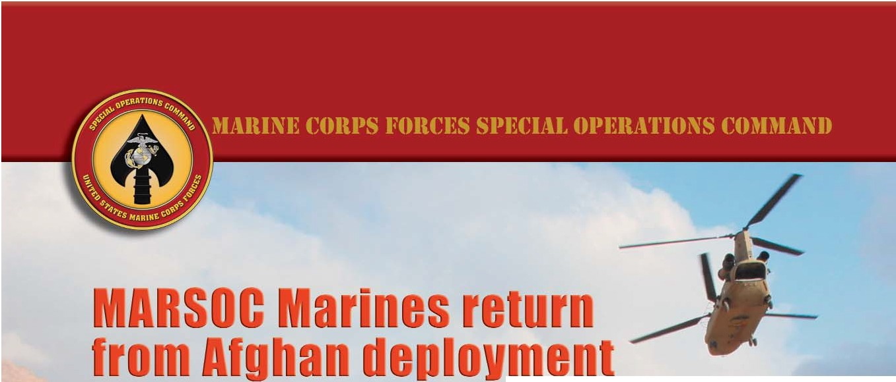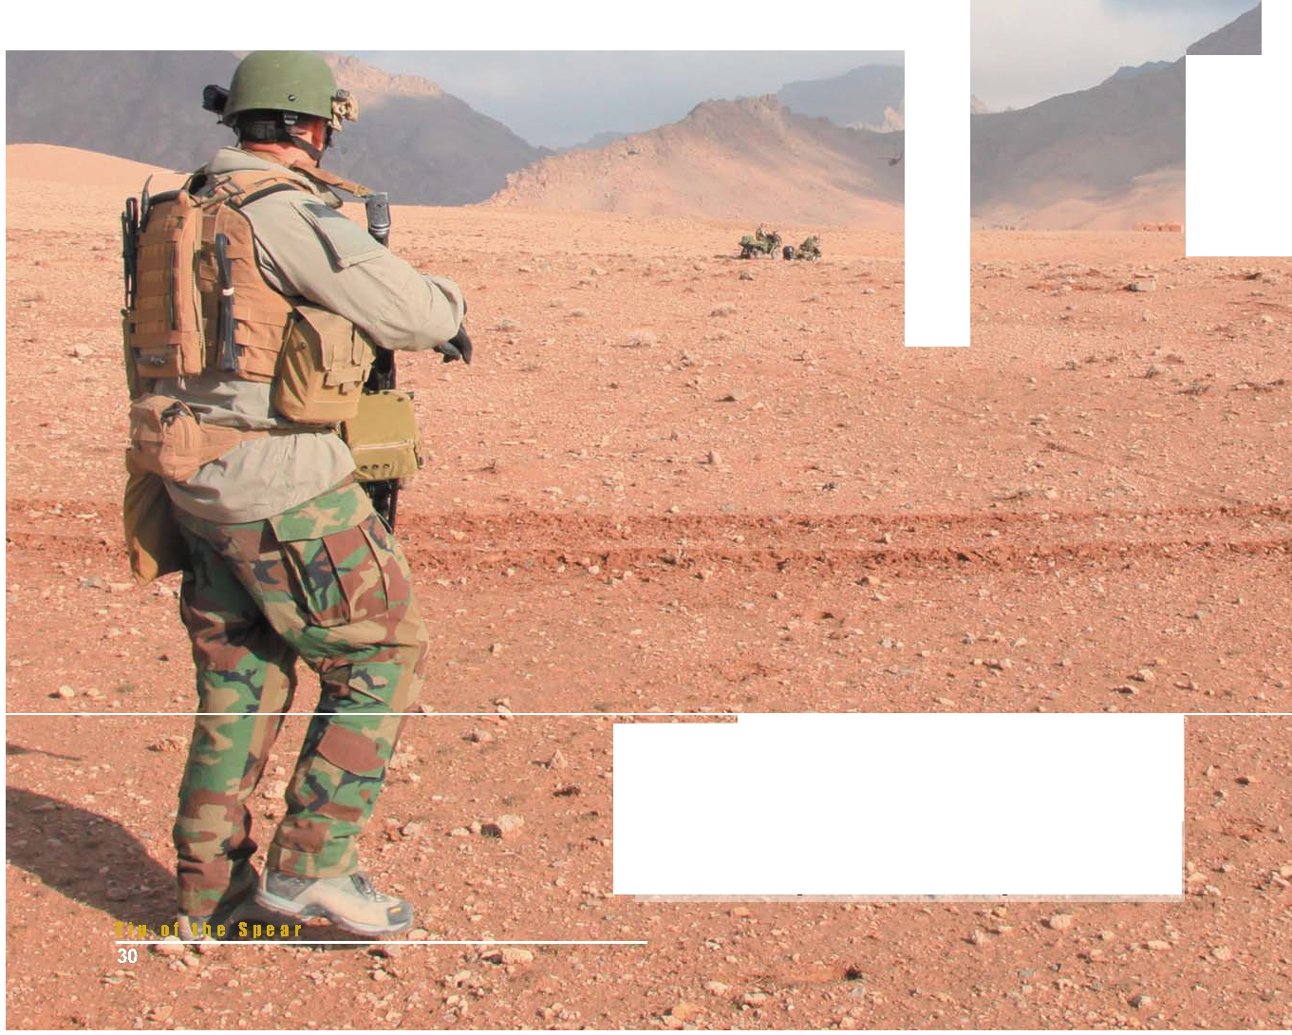

·-·

·

_.. ........ A Marine with U.S. Marine Corps Forces, Special Operations Command, watches a CH-47 Chinook helicopter depart after delivering Marines and Afghan Comandos to Farah province
for a two-day presence patrol Feb. 27. Marines with MARSOC"s
' 1st Marine Special Operations Battalion recently returned from •
a nine-month deployment to Afghanistan, where they
• commanded the Special Operations Task Force West and
"' oversaw one of Afghanistan's bloodiest regions. 1

Story and photos by Cpl. Kyle McNally
MARSOC Public Affairs

Marines with the 1st Marine Special Operations Battalion, U.S. Marine Corps Forces, Special Operations Command, returned recently from a demanding nine-month deployment, where as part of Special Operations Task Force – West, they commanded three companies of U.S. Special Operations Forces and oversaw one of Afghanistan’s bloodiest regions.
The deployment marks the third time MARSOC Marines have taken command of a SOTF downrange. As in past deployments, their accomplishments were numerous. SOTF-West, which oversaw more than
one-third of Afghanistan’s land mass, including Helmand, Nimroz, Farah, Herat, Ghor and Badghis provinces, became the first Special Operations task force to effectively transition an entire province to government of Afghanistan control. The transfer of Badghis, which was one of Afghanistan’s most kinetic areas as recently as last year, marks the rapidity of SOTF-West’s progress in the region.
Perhaps SOTF-West’s most noteworthy accomplishment was its thrust into the upper Gereshk valley, Nahr-e Saraj district, Helmand province; an area relatively untouched by coalition forces, and according to a SOTF report, one that is “the most violent district in all of Afghanistan.” SOTF-West designed and led an operation that consolidated over
14,000 troops from SOF, conventional, U.S. and international forces alike. The push into Nahr-e Saraj saw the establishment of three new coalition sites in the one-time insurgent stronghold, and allowed SOF to begin training and mentoring local Afghan defense forces in accordance with their Village Stability Operations mission.
VSO is U.S. Special Operations Command’s answer to the complicated issues of Afghan self- governance and the stabilization of security and socioeconomic conditions; objectives that are becoming increasingly critical as the clock winds down to 2014. VSO provides a platform for Afghans
to secure their nation, develop it, and govern it almost entirely through their own efforts.
To do this, SOF embeds themselves into Afghan villages and gains the trust of locals. They develop

Marines with U.S. Marine Corps Forces, Special Operations Command, prepare to board CH-47 Chinook helicopters as part of a two-day presence patrol with Afghan Commandos in Farah province Feb. 27.

and train an Afghan Local Police force, and legitimize the local government by working through it to address sources of instability for individual villages.
The mission is difficult, but SOCOM has made considerable gains.
MARSOC, though relatively new to special operations, has effectively kept stride with its veteran SOF peers since its inception in early 2006. MARSOC operators attribute this smooth integration to their Marine Corps roots.
“We grew up in the Marine Corps, so we all have
a combined arms mindset,” said a team leader with 1st MSOB. “Other organizations don’t train to the combined arms mindset like we do.”
“The Marine Corps is the smallest service,” added an Explosive Ordnance Disposal technician with 1st MSOB. “We have to do more with less. And we pride ourselves on the fact that we can do more with less, and I think that transfers over to the MARSOC
realm.”
Ultimately, however, MARSOC’s strength lies in the abilities of its individual Marines, and the fraternal bonds that only combat can forge, said the EOD technician.
“It’s a family; it’s an absolute brotherhood,” he said. “These guys live for each other every day, and it’s an honor to be a part of that.”

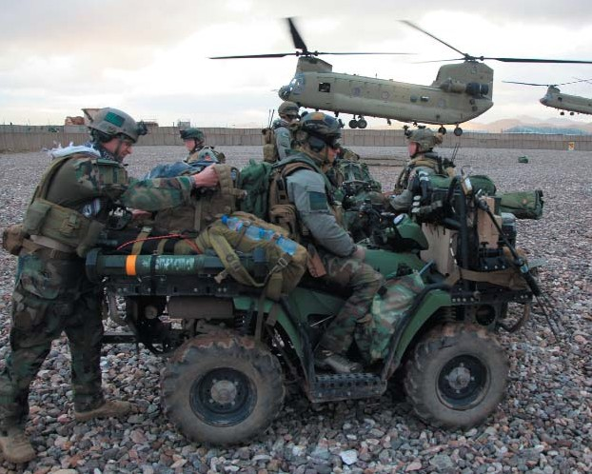
T i p o f t h e S p e a r
31

A 1st Marine Special Operations Battalion Marine patrols through poppy fields in Nahr-e Saraj district, Helmand Province, Afghanistan, April 3. Marines with MARSOC's 1st Marine Special Operations Battalion recently returned from a nine-month deployment to Afghanistan, where they commanded the Special Operations Task Force - West.

Afghan National Army Special Forces soldiers provide security as a convoy of Marines with the 8th Engineer Support Battalion, 1st Marine Expeditionary Force, and Marines with U.S. Marine Corps Forces, Special Operations Command, move into Nahr-e Saraj district, Helmand province, Afghanistan, June 20.
MARSOC Marines and Afghan Commandos conduct a two-day presence patrol in Farah province, Afghanistan, Feb. 27.

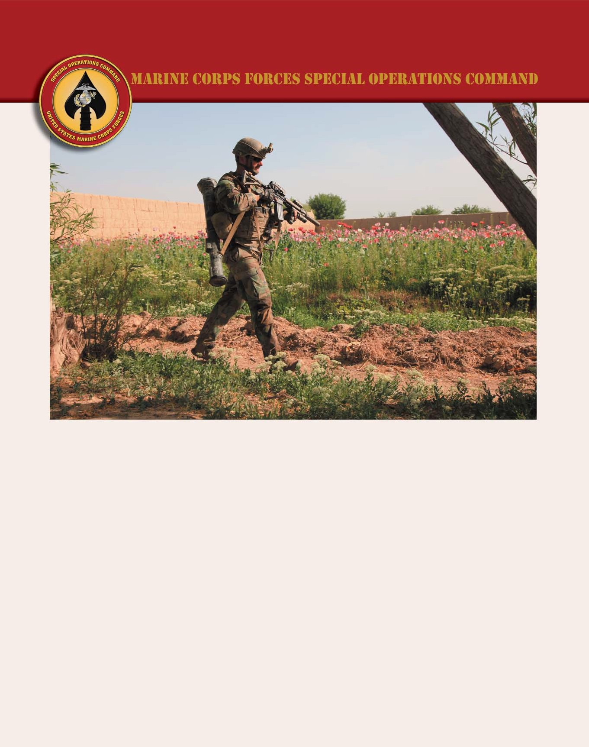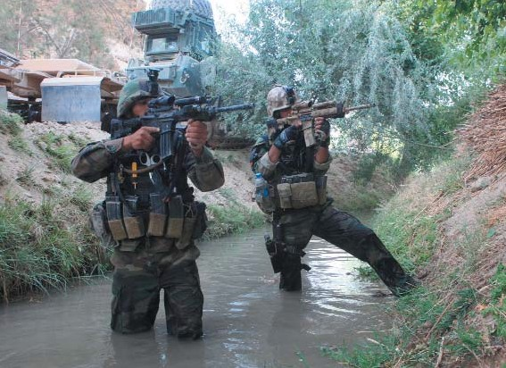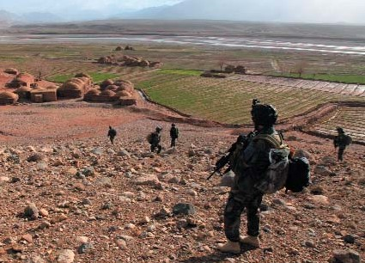
Photos by Marine Corps Cpl. Kyle McNally.
T i p o f t h e S p e a r
32

A MARSOC Marine provides security at a landing zone in Nahr-e Saraj district, Helmand Province, Afghanistan, March 28.

A MARSOC Marine waits in ambush for insurgents during a joint patrol with Afghan National Army Special Forces soldiers in Nahr-e Saraj district, Helmand Province, Afghanistan, April 3.
An Afghan National Army Special Forces soldier hands out soccer cleats to local children during a joint patrol with Marines from U.S. Marine Corps Forces, Special Operations Command in Nahr-e Saraj district, Helmand province, Afghanistan, March 15.

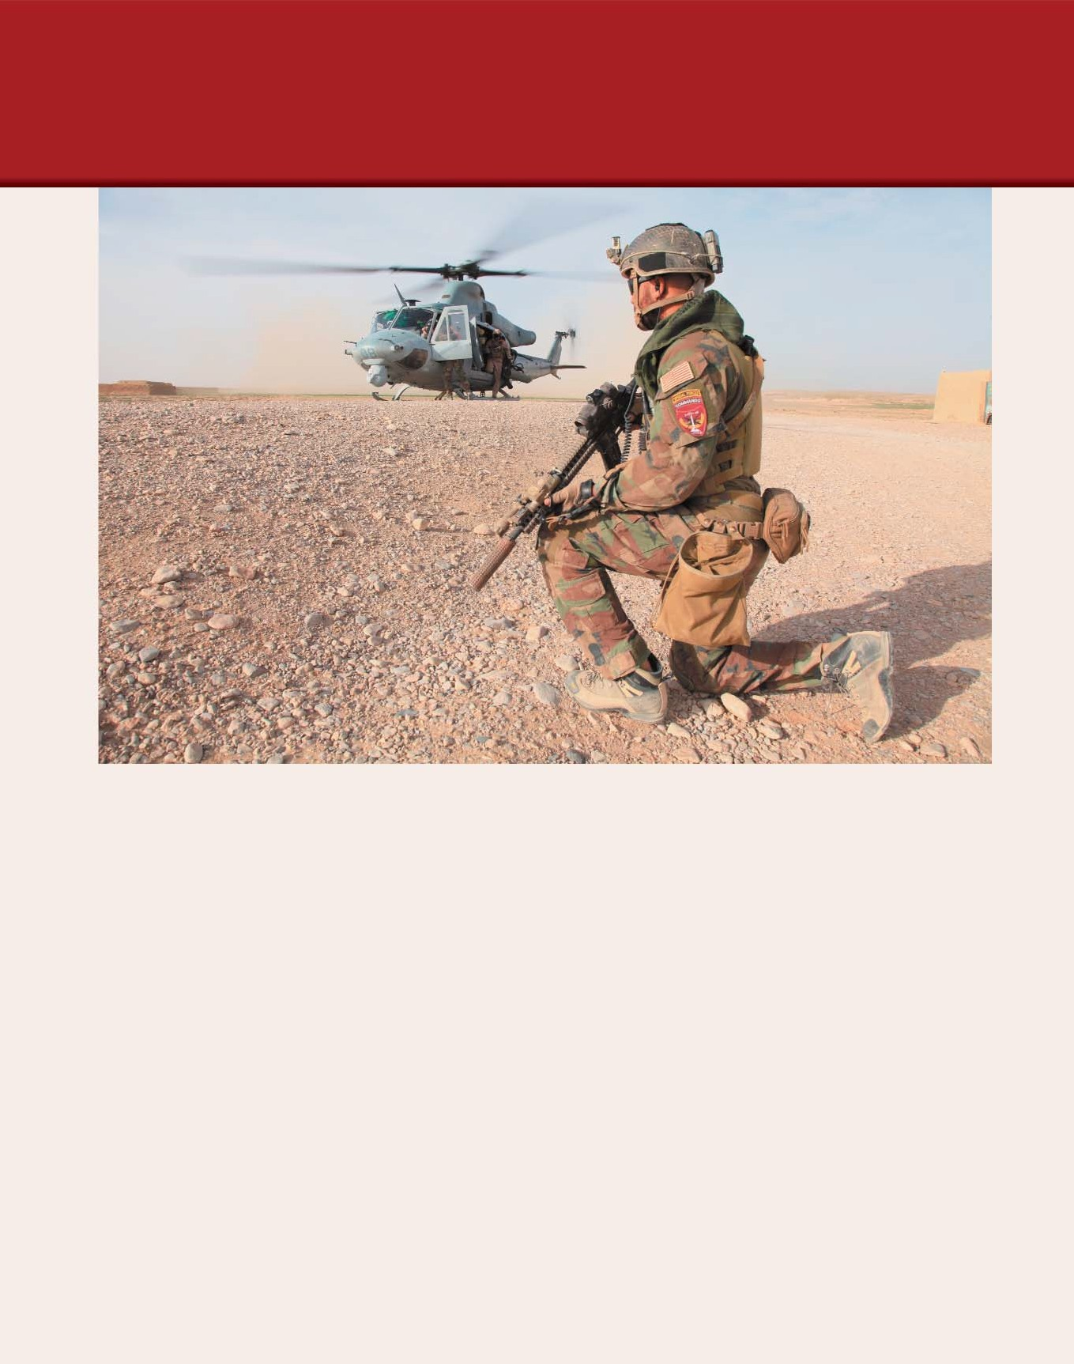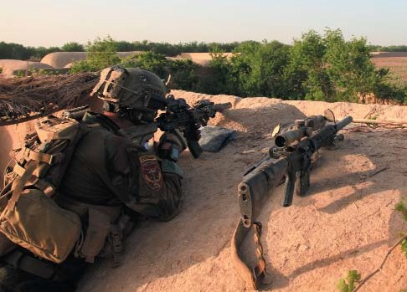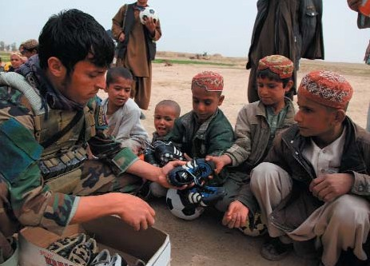

T i p o f t h e S p e a r
33

USSOCOM wins first-ever DOD
Better Buying Power Efficiency Award

By Beth Ritter and Mike Bottoms
SORDAC Director’s Action Group and USSOCOM Public Affairs

A Special Forces A-Team is on patrol in Helmand province, Afghanistan, when it suddenly comes under attack. An improvised explosive device is detonated and two Special Forces Soldiers are badly wounded. A medic
rushes in through the acrid smoke and sees one Soldier with a badly injured lower torso and the other with a ruptured femoral artery. The medic applies an Abdominal Aortic
Tourniquet from his Casualty Evacuation Kit to the Operator with the badly injured torso, stopping the flow of blood. The medic decides to use a Combat Ready Clamp to stop the flow of blood from the Soldier with the femoral artery wound. The medic then pulls out freeze dried plasma developed by French scientists to treat both Soldiers and saves their lives.
Two years ago the medic would not have had the Casualty Evacuation Set with the specialized tourniquets, clamps, and medical instrumentation; thus, saving the lives of the Soldiers would have been much more difficult.

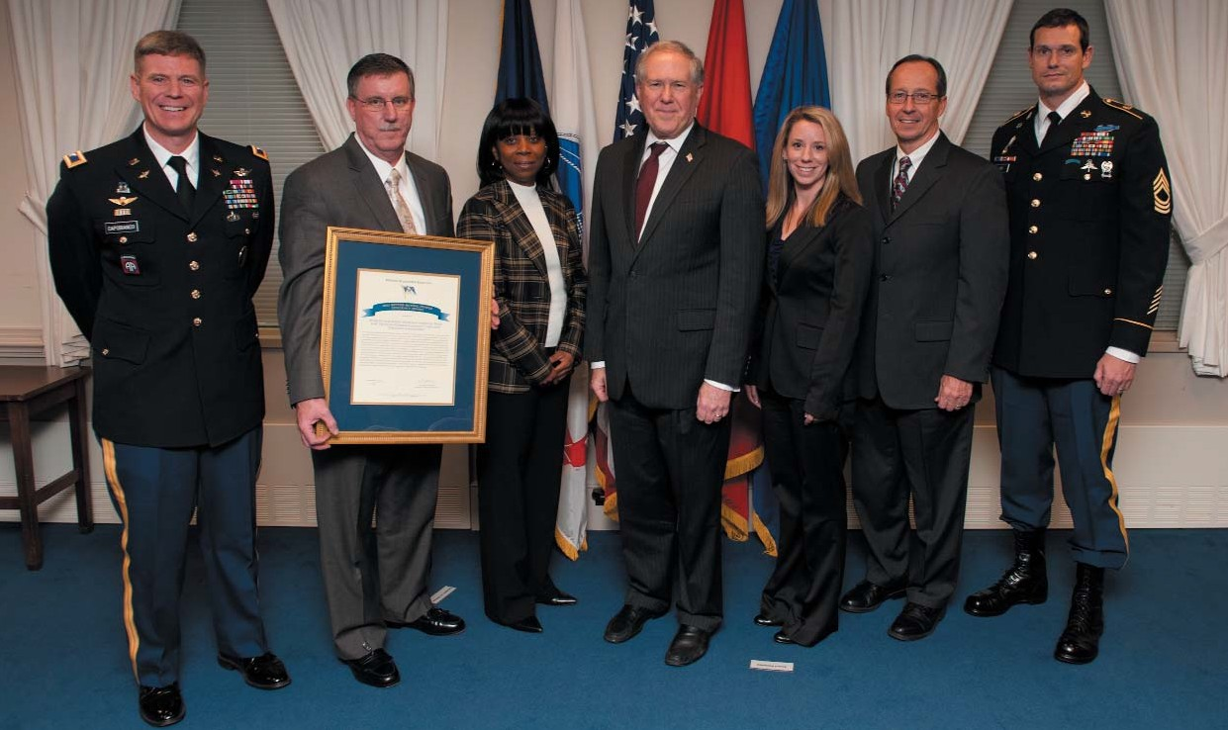

From left to right) Col. Joseph Capobianco; Mr. Tom Mills; Ms. Leatrice Frederick; the Honorable Frank Kendall, under secretary of defense, acquisition, technology and logistics; Ms. Stephanie Elder; Mr. James Cluck; and Master Sgt. Kyle Sims stand after the Special Operations Research, Development, and Acquisition Center and its Acquisition Rapid Response Medical Team for Tactical Combat Casualty Care and Casualty Evacuation were selected as the first-ever recipient of DOD’s of the Better Buying Power Efficiency Award for fielding the Special Operations-peculiar life-saving kit in less than two years. Photo by U.S. Navy Petty Officer 1st Class Chad J. McNeeley.

T i p o f t h e S p e a r
34

The Special Operations Research, Development, and Acquisition Center and its Acquisition Rapid Response Medical Team for Tactical Combat Casualty Care and Casualty Evacuation were selected as the first-ever recipient of DOD’s newest award: the Better Buying Power
Efficiency Award for fielding the Special Operations- peculiar life-saving kit in less than two years. The award was presented to Army Col. Joseph Capobianco, program executive officer for SOF warrior systems, and his team on Nov. 2, by Secretary of Defense Leon Panetta during a ceremony at the Pentagon.
“Success has many fathers,” said Capobianco. “We used the SOF acquisition model which streamlines the acquisition process and made sure we had inclusivity and ownership from the Special Operator, the contracting office, and the combat and material developers.”
Capability gaps were identified in Special Operations Forces battlefield trauma care assessment by operators in the field, driving the need for a modernized, modular Casualty Evacuation Set.
The PEO Survival staff and Program Manager SOF Survival, Support, and Equipment Systems teams coordinated with each of USSOCOM’s component surgeons to create a joint service, multi-talented team to
develop, test, and field the Casualty Evacuation System set, offering a multitude of pioneering capabilities to attend to casualties under a variety of conditions at the point of
injury on the battlefield, often times in remote, denied access areas.
“Each of the component’s surgeons and their supporting combat medics were part of the acquisition and contracting process from the very beginning,” said Duke Dunnigan, director of operations, program executive office, SOF warrior systems. “Their medical expertise was critical to successfully complete the field evaluations of medical equipment provided as bid samples by industry.”
“A strong partnership formed with our team medics and is why we were successful in fielding the Casualty Evacuation Set in record time,” said Dr. John Parson, program executive officer SOF warrior systems.
The team led the way in developing and widely fielding a comprehensive, modularly configured Casualty
Evacuation set, enabling ground units to provide innovative, life-saving medical treatments at the point of injury to stabilize the casualty; and provide mobility to deliver a casualty from a remote, inaccessible area to a
ground or air extraction platform for transport to a field medical hospital.
“We packaged Casualty Evacuation Set so that all of the medical supplies could be immediately accessed,” said Stephanie Elder, assistant program manager, tactical combat casualty care, SOF survival, support, and equipment systems. “The kit is modular, easy to transport, and we have received positive feedback from the Special Operators.”
The acquisition team developed a Combat Ready Clamp and an Abdominal Aortic Tourniquet, two medical devices to achieve, within the “golden hour,” life-saving hemorrhage control on groin and abdominal wounds previously considered non-treatable at the point of injury. The team also successfully navigated through intense regulatory hurdles to gain approval for the use of a French freeze dried plasma product that can be reconstituted at the point of injury and administered to prevent shock and death from hemorrhaging at the point of injury.
“We went through 1.2 million data points to score the equipment,” said Thomas Mills, program manager and lead material developer from SOF survival, support, and equipment systems. “The scoring allowed us to scientifically select the best medical equipment and we
fielded 56 kits to the Special Operator by June 2012 and the fielding of kits will continue through fiscal year 2015.”
The SOCOM accelerated acquisition process utilized a combined developmental and operational testing approach to compress normal acquisition cycle times. Equally as important to the accelerated acquisition process were the contributions from the contracting office.
“Our office was brought in at the very beginning of this project,” said Susan Griffin, contracting officer,
procurement directorate, SORDAC. “It only took four months for us to get the project off the ground and we supported the effort to the end.”
The Casualty Evacuation Set acquisition process was efficient because affordable, off-the-shelf technology was utilized, reducing a normal acquisition time from start to finish from five to two years. The use of existing technology and the speed the technology was put in the warfighter’s hands are why the team was selected for the Better Buying Power Efficiency Award.
“We leveraged an established solution to solve a capability gap,” Capobianco said. “We closed that capability gap with effective, timely, and affordable technologies. What our team did will save lives.”



T i p o f t h e S p e a r
35

Founding of the Joint
Special Operations Universit y

The evolution of Joint Special Operations For ces education

By Rick Green
USSOCOM History & Research Office

Today's Joint Special Operations University (JSOU) traces its origins to the legislation that established U.S. Special Operations Command itself. That legislation
directed USSOCOM to conduct specialized courses of instruction for commissioned and non-commissioned
officers and to monitor the professional military education of SOF personnel.
The first effort to establish a joint SOF
organization of higher learning began under Gen.
Wayne Downing in 1993. USSOCOM 13-Training (13- T) was tasked to develop a proposal and, based on

As coordinator
for SOF professional military education
and training, JSOFI
conducted numerous conferences,
coordinated the guest- speaker program,
developed joint and common SOF
manuals and
directives, and
reviewed joint- doctrine

Gen Wayne A. Downing

input from the components and senior SOF leaders, it modeled the University after the Army’s Training and Doctrine Command. 13-T called their proposal
the Joint Special Operations Forces I (JSOFI) and, to ensure it was viewed
joint, recommended that it be based a
MacDill Air Force Base, Fla., and report to the USSOCOM J5.
Downing approved the concept in
April 1994.
But the J5 was not prepared to assume oversight of JSOFI, so
Downing directed it be situated at Ft. Bragg under the purview of the commander of the Army Special Warfare Center and School
(SWCS), with the SWCS
commander dual-hatted as the
school’s commandant. Ironically,
Downing had all along wanted JSOFI moved to Ft. Bragg and away from t USSOCOM headquarters so it could
independently, believing SWCS and the associated museum were repositories of SOF knowledge.
publications. JSOFI developed computer-based training
and also wrote the first SOF reference manual in 1997, which provided a single reference on SOF
ents and a platform to facilitate unit- taff-level war games.
nstitute compon as and s
t
a

f
S
fro
he for JS
work The l
Still, some viewed JSOFI as having flawed organization that was neither
truly joint nor speaking for the
USSOCOM commander on joint
issues. This was due in part to its
collocation with and appearance of being imbedded within SWCS.
This perception may have
contributed to the USSOCOM
board of directors' decision in 1996 when it voted to disestablish JSOFI within two years. JSOFI was saved
or the moment when Gen. Henry helton, USSOCOM's commander
m 1996-97, intervened. The manning
OFI, however, was reduced.
oss of billets raised the question whether JSOFI could still function, and in the
summer of 1997 USSOCOM stood up a process action

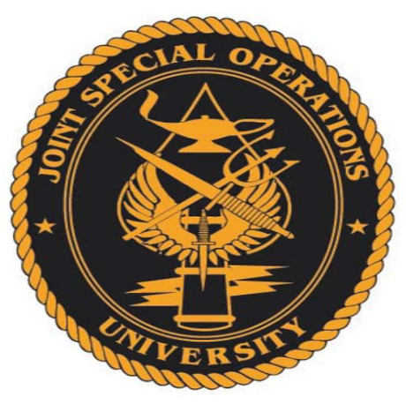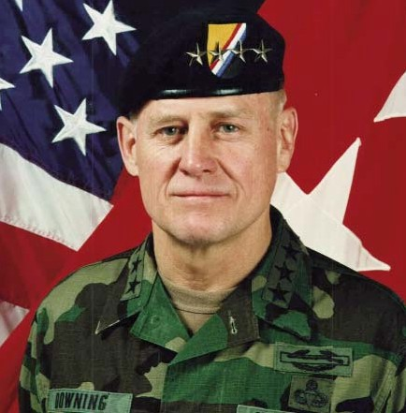

T i p o f t h e S p e a r
36

team assigned to relook JSOFI in multiple areas,
including manning, location, and reporting senior. In July, The SOJ5/7 outlined the team's results and the USSOCOM commander's decision. Shelton accepted
the recommendations to keep JSOFI at Ft. Bragg and to change the commandant position to an 06 who would
report to USSOCOM, where it was put under Maj. Gen. Maxwell C. Bailey in the Operations and Plans Center. Before that occurred, however, the decision was made
to disband JSOFI and move those functions back to
USSOCOM. This was briefed to the new USSOCOM
commander, Gen. Pete Schoomaker, who approved the plan. JSOFI was given one year to move and in 1998
was disestablished.
The disestablishment of JSOFI did not end what some saw as a need for an organization outside of
USSOCOM to work through the professional military
education system to instruct the joint community on the utility of SOF. Discussions started again in 1999 about
establishing a SOF university, and the idea gathered
support after multiple briefings to Schoomaker and the
USSOCOM staff. The difference would be that, whereas the JSOFI had been a staff element that
coordinated instruction, the new institution would be in the business of delivering instruction.
Modeled on the U.S. Air Force Special Operations
School at Hurlburt Field, Fla., JSOU was established on
June 15, 2000, at Hurlburt Field. Its original charter stated that “JSOU is a direct reporting, unified,
subordinate element of USSOCOM and shall be
organized to facilitate Title 10 responsibilities of the
CINC [commander in chief] to conduct specialized courses of instruction for commissioned and
noncommissioned officers and to monitor the
professional military education of SOF officers.” The USSOCOM Board of Directors was designated as the JSOU Board of Regents.
In establishing JSOU, Schoomaker noted that the
school would leverage and enhance existing joint and
service professional military education programs. JSOU
provided education to U.S. SOF and to the people who enable the SOF mission in a joint environment. In
addition to the regular courses, JSOU conducted both
regular and tailored activities for SOF units worldwide by means of remote on-site instruction and video tele-
instruction.
In 2008, USSOCOM designated the president of
JSOU, Dr. Brian A. Maher, as “the joint SOF
educational component of USSOCOM” and to “serve as the USSOCOM Lead Component for all matters
pertaining to joint SOF education.” In 2010 JSOU
relocated to a new campus near MacDill and that same year conducted the first Joint Special Operations Force Senior Enlisted Academy Course. The school has
continued to grow and expand its reach. During the
2011 academic year, JSOU saw 5,976 students pass through its doors, a 25 percent increase over the
previous year. JSOU was also recognized as part of
USSOCOM's International Engagement Program, and,
among its many accomplishments, was the deployment of Joint Mobile Education Teams to 26 countries.

Dr. Brian A. Maher is president, Joint Special Operations
University. Courtesy photo.

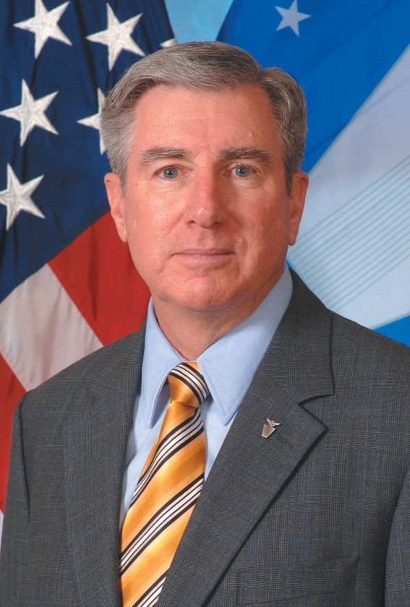

T i p o f t h e S p e a r
37

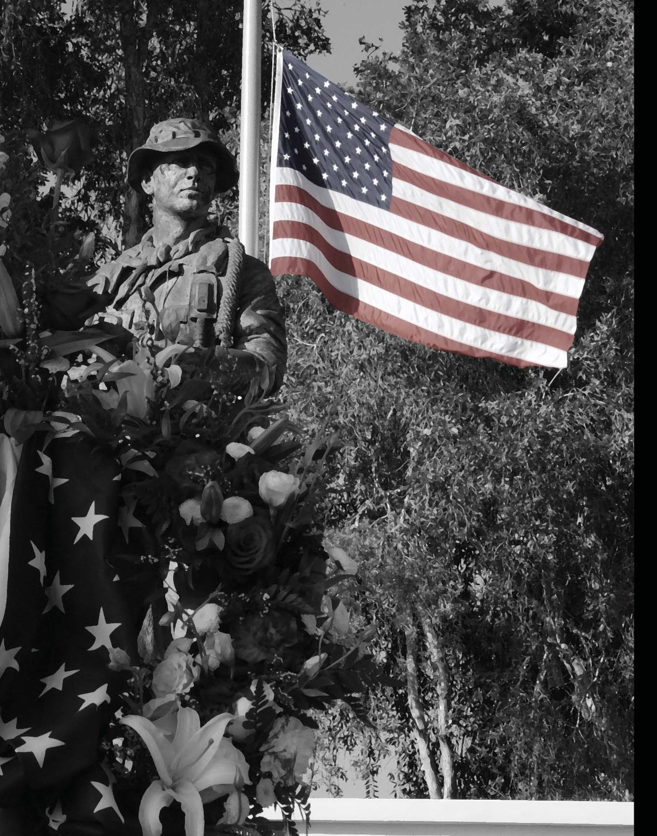

T i p o f t h e S p e a r
38

Petty Officer 1st Class
(SEAL) Nicolas D. Checque
Naval Special Warfare Command
Army Chief Warrant Officer 2
Michael S. Duskin
3rd Special Forces Group
(Airborne)
Petty Officer 1st Class
(SEAL) Kevin R. Ebbert SEAL Team 4

Army Capt. Shawn G. Hogan
5th Special Forces Group
(Airborne)
Petty Officer 2nd Class
(SEAL) Matthew G. Kantor SEAL Team 4
Army Staff Sgt. Kashif M. Memon
95th Civil Affairs Brigade
(Airborne)

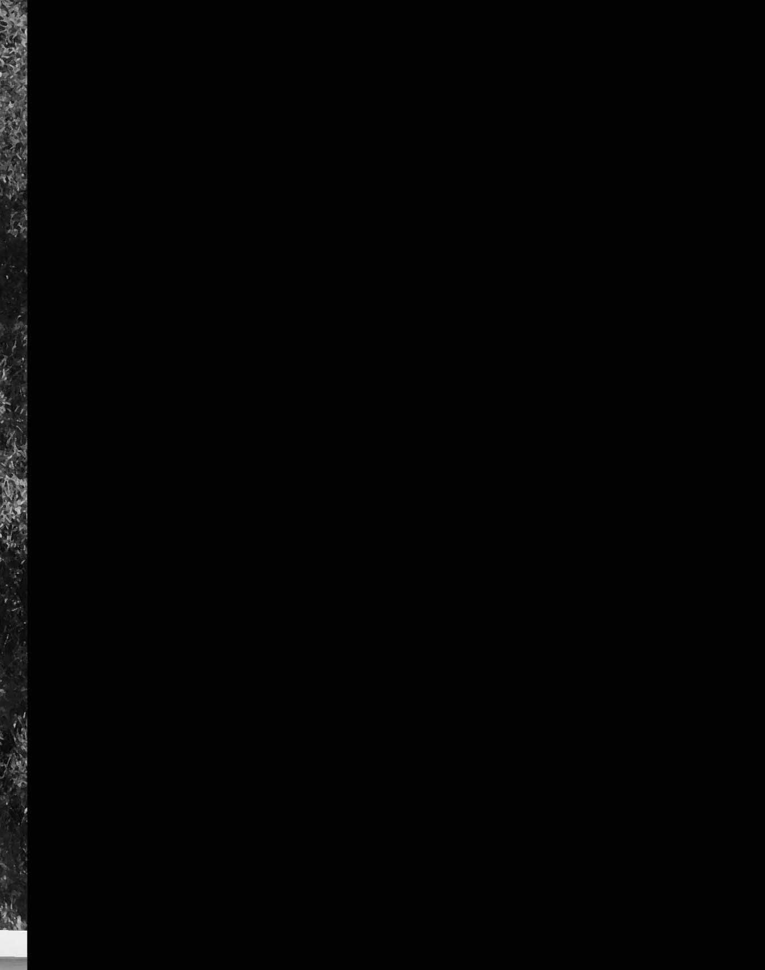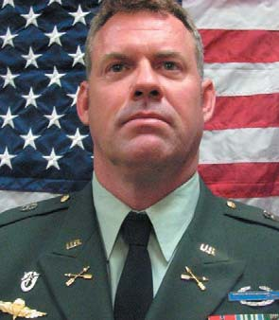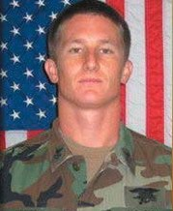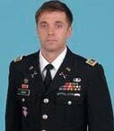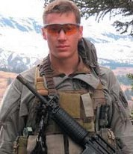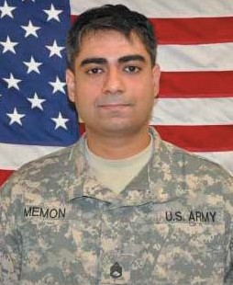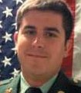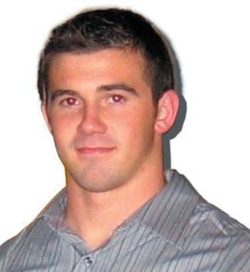

Editor ’s note: Honored are Special Operations Forces who lost their lives since October ’s Tip of the Spear.

Army Sgt. Clinton K. Ruiz
9th Military Information Support
Battalion (Airborne)

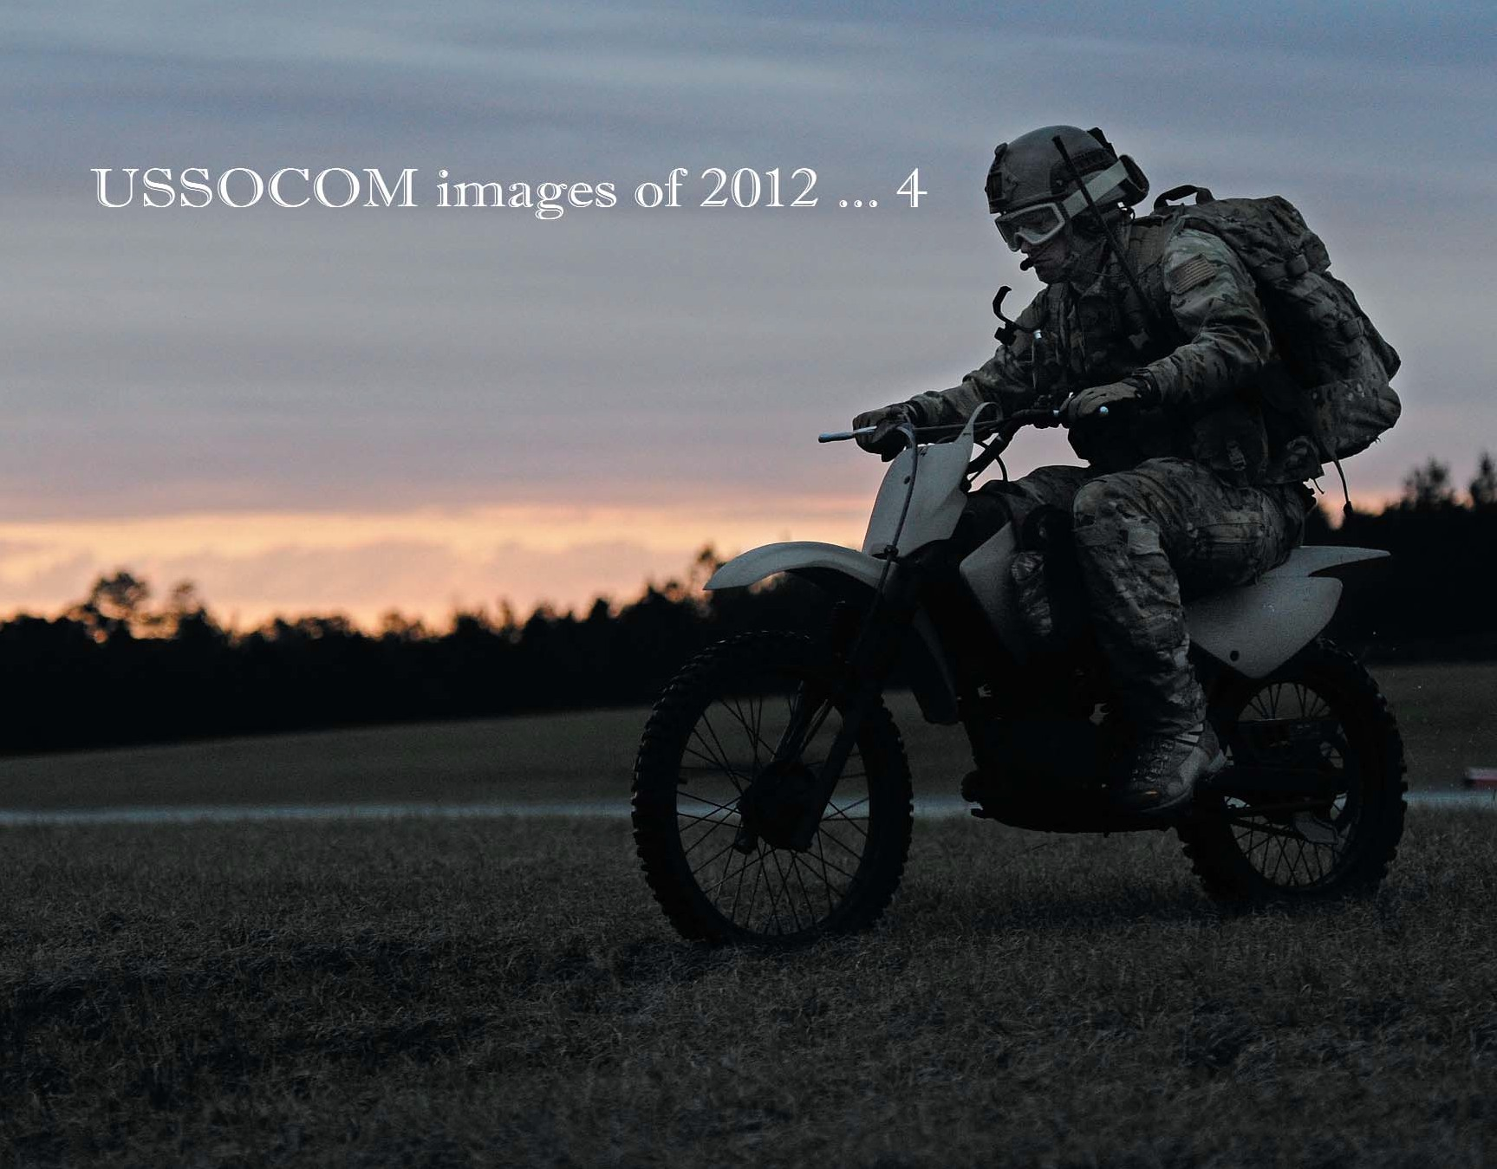

A combat rescue officer rides a minibike at the Camp Shelby Auxiliary Field runway during the Emerald Warrior exercise March 3. Photo by Tech. Sgt. Charles Larkin Sr.

